How do the oceans affect contemporary atmospheric CO₂?
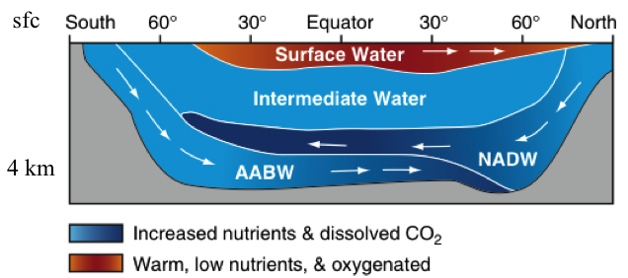
Over millions of years, it’s safe to assume that the chemistry of ocean water is in chemical equilibrium with atmospheric CO₂ and that the long-term balance is controlled by volcanic emissions and weathering reactions on land. But over periods of decades to centuries this is not the case because the oceans are thermally stratified. The cold water is denser and sinks to the bottom, with only a thin skin of sun-warmed water floats buoyantly on the top like a raft. The “body” of the oceans very cold with a nearly uniform temperature of about 3 Celsius (37 F), even in the deepest tropics. The raft of warm water on top is only 100 to 200 m thick in most places, and it’s this much smaller volume of water that’s in chemical equilibrium with the atmosphere.
North Atlantic Deep Water
Antarctic
Bottom Water
We’ve seen that CO₂ can dissolve in water to make carbonic acid, which dissociates into hydrogen ions, bicarbonate ions, and carbonate ions. It’s this chemistry that gets CO₂ to dissolve into the oceans, but the warm surface water quickly becomes saturated. The “rate-limiting step” to getting CO₂ out of the atmosphere is the mixing of surface waters into the deep oceans. This is very slow because the vertical mixing of the oceans has to fight against buoyancy: we want warm water to sink and clod water to float!
The Solubility Pump
At the highest latitudes, around Greenland and Antarctica, the surface ocean gets colder in winter than even the deep ocean. Around 1/1000 of the mass of the ocean sinks in these regions every year. This North Atlantic Deep Water (NADW) and Antarctic Bottom Water (AABW) flows toward the Equator at great depth and forces cold water to rise in the Tropical Pacific and Indian Oceans. CO₂ dissolves much better in cold water than warm, so NADW and AABW carry a lot of CO₂ to Davy Jones Locker. This slow overturning circulation of the deep oceans takes about 1000 years to mix once. Oceanographers have found little “tongues” of cold polluted water with extra CO₂, CFCs, and radioactive isotopes from nuclear tests creeping along the bottom of the oceans. But the great mass of the deep ocean hasn’t touched the atmosphere since the High Middle Ages. It doesn’t know we’re here yet!
The Biological Pump
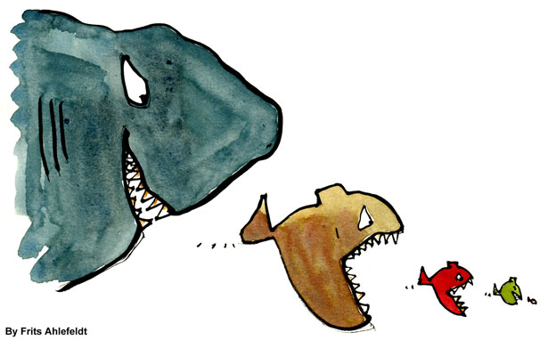
The very slow delivery of fossil fuel CO₂ to the deep ocean by the solubility pump outlined above is aided by marine biology. Dissolved CO₂ is taken up through photosynthesis, mostly by single-celled algae called phytoplankton. Unlike on land where the average residence time of a carbon atom in a plant is 10 years or so, a marine carbon atom remains in organic form only about a day on average. Phytoplankton are “grazed” by microscopic herbivores called zooplankton, which respire the carbon back into solution. Once in a while a little zooplankter is eaten by a bigger zooplankter which can get eaten by an even bigger one and so on.
The marine food chain can concentrate organic carbon into bigger particles which sink faster than smaller particles through the water. A very few particles actually sink deep enough that carbon is only respired back into dissolved CO₂ below the level where it’s light enough for photosynthesis to reabsorb (a few hundred meters). These sinking particles at depth are euphemistically called “marine snow,” but mostly they are made of plankton poop.
The steady fall of marine snow from the surface food web into the deep dark ocean adds dissolved CO₂ (and nutrients) to deep water as it makes it 1000-year journey from the icy waters around Greenland to the balmy surface waters of the Indian Ocean. The longer the water has been down there the more carbon it accumulates.
Bomb Testing was Good for Oceanographers
When I was a little kid, the US and USSR did a terrible thing: they blew up hundreds of nuclear weapons in the atmosphere. Most were detonated in 1961-62, immediately before the Nuclear Test Ban Treaty went into effect. This had the unintended effect of creating a massive pulse of radioactive atmospheric CO₂ (¹⁴CO₂). The ¹⁴CO₂ produced in the bomb tests behaves biologically and chemically just like any other CO₂. The only difference is that it is easy to detect, and we can tell without any doubt that it was in the atmosphere in 1962. Oceanographers have learned an amazing amount about the way CO₂ gets into the deep ocean by tracing bomb-derived ¹⁴CO₂ over the past 50 years. They know how much CO₂ gets into the oceans, where and when and how it sinks, and where it is now. Without this inadvertent “tracer” experiment, we would know much less about how long the CO₂ from fossil fuel burning will last in the atmosphere.

