Kagan Corners
Dr. Spencer Kagan has many publications and workshops on effective cooperative learning and higher-level thinking engagement strategies. The backbone of this activity can be further researched by reading his materials on “classbuilding.”

Step 1: Announce corners - Have a sign in each corner with a topic that is conducive to being discussed with a general question or two. There should be 3-5 “corners” to group into. (Example 1: winter, spring, summer, fall – first corner question is, “Show the position of the sun and Earth in that season.” Example 2: Do you prefer sandals, hiking boots, or tennis shoes? Justify your reasons. )

Step 2: Think and write time – Give students a bit of silent time to clarify for themselves either their preference (if they will be choosing a corner) or their answer to a corner question (if you will be assigning corners.) If you will be assigning corners, tell them the first corner question and let them process for a minute. (Requiring students to write something forces students to make a commitment if they are selecting their own corner, so they don’t just “hang out with a friend.” It also allows students think time.)

Step 3 – Students group in corners – Have students move to the corner of their written preference or number students so they know which corner they will be starting with. If a corner has a large group, have students break into smaller groups of 3 or 4 to discuss the question. (The people who are talking are doing the learning, so the more people that talk, the more learning is happening.)

Step 4 – Share out – A spokesperson from each corner shares answers/reasoning from each corner. Students in pairs in each corner paraphrase what each spokesperson says.

Step 5 – Teams review – When students are back in their teams, they compare/contrast answers and make sure everyone can justify answers with evidence and reasons.

Climate forcing, feedbacks, and sensitivity corners

Post the following signs in the corners (or other gathering spaces) in the room. Pose the first question and give think time. Number students by 4’s, and have them move to the correct sign to discuss the first question. Share out. Either rotate or not, depending on time, and ask the second question.
- Explain an example of this (corner sign.)
- Describe how a change in (this corner) would impact the climate.
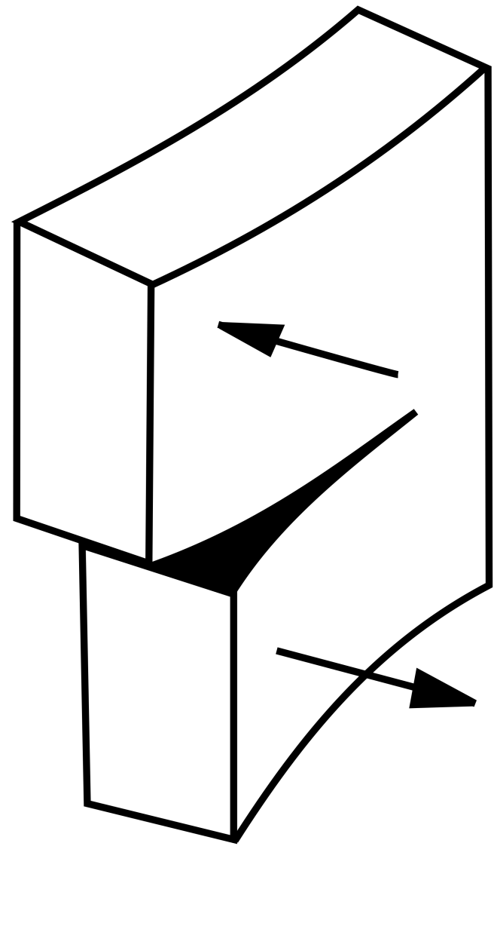
1

Climate Forcing
2

Positive Feedback

3

Negative Feedback
4
T⁴

Climate
Sensitivity

