Student Data for Graphing Quaternary CO₂
By Vicky Jordan
Cut apart data sets in 10,000 year increments. Give one data set to each student (or group) to graph using the same graph paper so scales are identical. Associated pictures should be cut out by the student and fastened to their graph to make an infographic. Additional information can be added to the graph where appropriate. Students could add sticky notes to areas of the graph based on their research or to make inferences about what may have been happening on the planet at various times. For further research: http://www.environmentcounts.org/articles?topic=4&offset=30

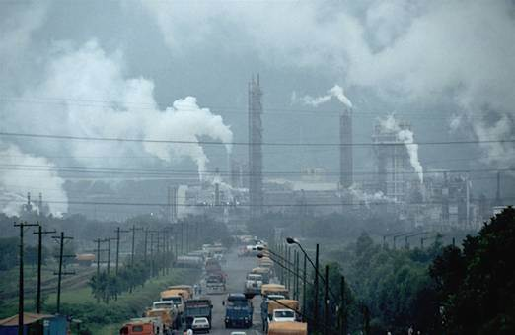
10,000-0 Years Before Present
Age(yrBP) | CO2(ppmv)
9983 | 264.9
9092 | 260.6
8050 | 260.7
7112 | 258.4
6039 | 262.7
5094 | 267.6
4004 | 271.6
3053 | 276.3
2057 | 276.7
1552 | 280
1060 | 279.1
950 | 276.6
559 | 281.1
268 | 274.9
137 | 280.4
56 | 317.3
43 | 328.6
35 | 339.3
25 | 355.1
10 | 379.6
0 | 401.9

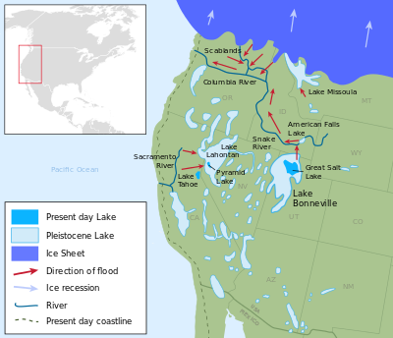
Pluvial lakes dry up, one of them forming the Great Salt Lake in Utah. Sea level rises as ice sheets and glaciers melt.
Atmospheric carbon dioxide due to the burning of fossil fuels is at a record high.
Age(yrBP) | CO2(ppmv)
19988 | 188
19347 | 188.7
18285 | 187
17111 | 193.9
16073 | 207.5
15012 | 224.5
14303 | 228.5
13090 | 237.9
12050 | 243.2
11014 | 264.2
10088 | 267.5
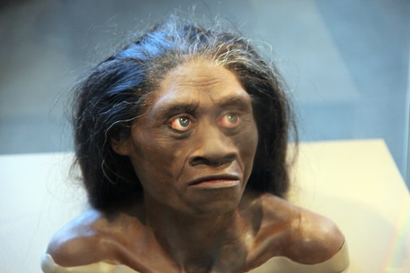
20,000- 10,000 Years Before Present
10,000-20,000 Years Before Present

Homo floresiensis becomes extinct

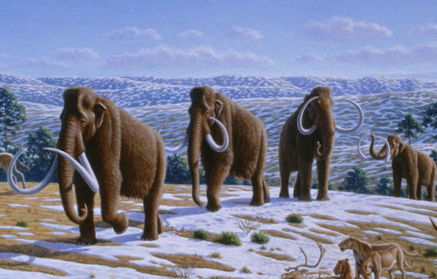

Pleistocene epoch ends & Holocene epoch begins 11,700 years ago

Mammoths, saber-tooths and other Pleistocene animals become extinct as the grass steppes disappear with a changing climate..

Age(yrBP) | CO2(ppmv)
29063 | 188.5
25994 | 191.6
22827 | 189.2
22015 | 184.4
21011 | 186.5
20197 | 195
20168 | 188.2
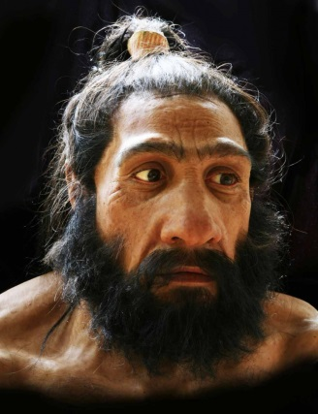
30,000- 20,000 Years Before Present

Homo neanderthalensis becomes extinct

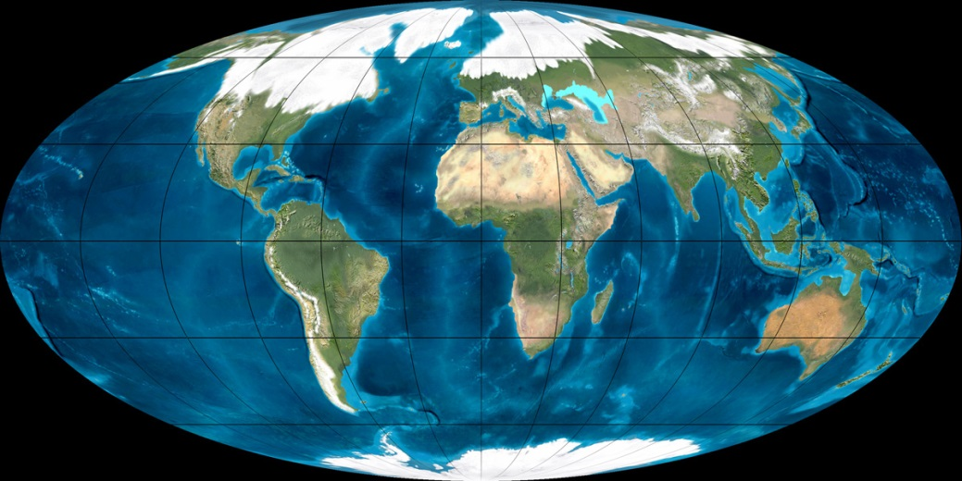

Glaciers cover most of North America; land bridges exist between Russia and Alaska and also between England and Europe because the ocean water is tied up as ice and sea levels are low.

40,000- 30,000 Years Before Present
Age(yrBP) | CO2(ppmv)
37471 | 209.1
35009 | 205.3
30020 | 191.7

Lake Bonneville and other pluvial lakes form from glacial melt and wet climate conditions near the ice sheet.

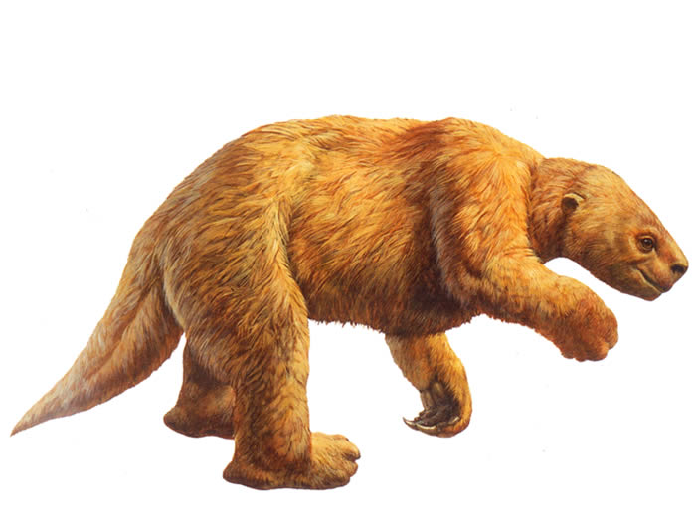
50,000- 40,000 Years Before Present
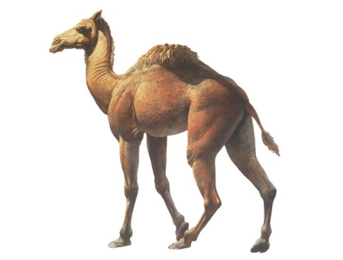
Age(yrBP) | CO2(ppmv)
49690 | 210.1
48854 | 188.4
47336 | 189.3
43500 | 209.1

Giant ground sloths, camels, and mastadons live in California. Pleistocene animals migrate throughout North America and cross a land bridge from Russia.

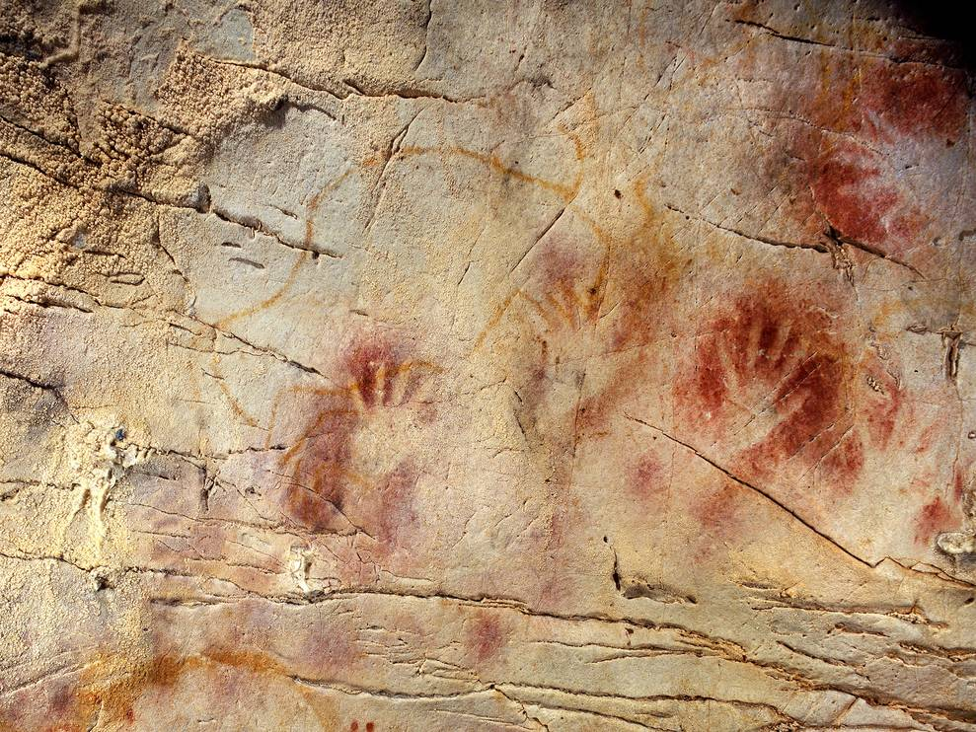

60,000- 50,000 Years Before Present

Age(yrBP) | CO2(ppmv)
57657 | 210.4
57088 | 221.7
52382 | 190.4
50663 | 215.7

Homo neanderthalensis most likely develops cave art. More study is needed to determine this conclusively.
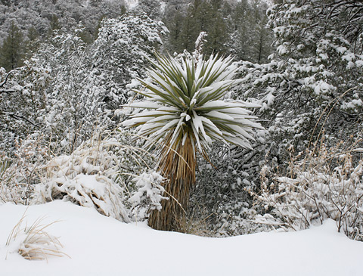

70,000- 60,000 Years Before Present

Age(yrBP) | CO2(ppmv)
65939 | 194.9
64939 | 191.4
62859 | 195.3
Global temperatures fall as carbon dioxide levels drop.

80,000- 70,000 Years Before Present
Age(yrBP) | CO2(ppmv)
78183 | 221.7
77150 | 217.1
73227 | 229.1
71049 | 227.3

90,000- 80,000 Years Before Present

Age(yrBP) | CO2(ppmv)
87917 | 208
86181 | 217
85020 | 214.2
84016 | 228
83333 | 236.4
82417 | 241.1
80614 | 230.9

100,000- 90,000 Years Before Present
Age(yrBP) | CO2(ppmv)
99849 | 225.8
94353 | 232
91249 | 228.3
90357 | 224.2

Homo floresiensis first appeared in Indonesia

110,000- 100,000 Years Before Present

Age(yrBP) | CO2(ppmv)
109804 | 251.2
108153 | 245.6
107579 | 238.2
105636 | 230.6
104704 | 236.9
103465 | 228.1
101749 | 236.9
100837 | 230.8

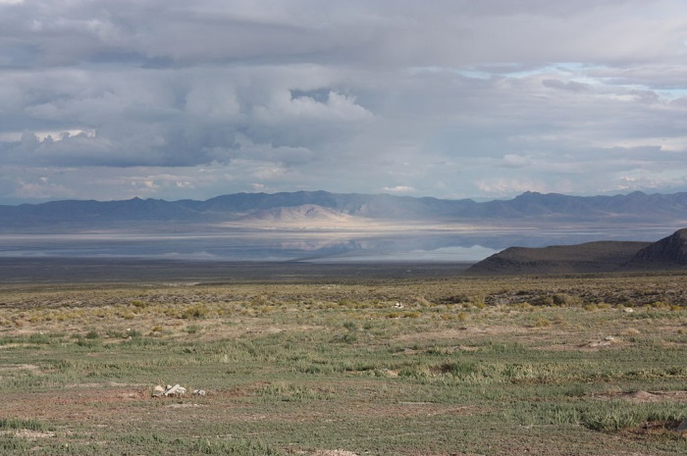
120,000- 110,000 Years Before Present
Pluvial lakes dry up during an interglacial period leaving salt flats and arid regions.
Age(yrBP) | CO2(ppmv)
119672 | 271.9
118649 | 273.7
117750 | 267.6
116501 | 262.5
115118 | 273.2
114601 | 274.5
114096 | 261.4
113262 | 266.3
111862 | 256.7

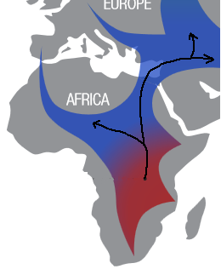
130,000- 120,000 Years Before Present
Homo sapiens migrate out of Africa into the Middle East. This may have been possible due to an increase in global temperatures.
Age(yrBP) | CO2(ppmv)
129736 | 259
129146 | 264.1
128372 | 287.1
127132 | 262.6
126347 | 273.7
125081 | 279.7
124213 | 268.7
123070 | 276.4
122344 | 272.1
121017 | 277.6
120382 | 265.2

140,000- 130,000 Years Before Present
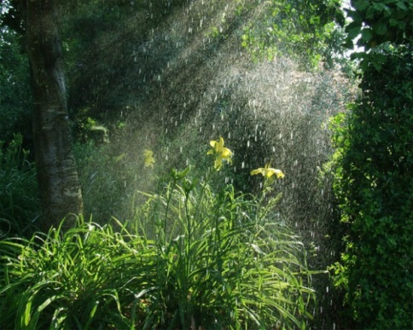
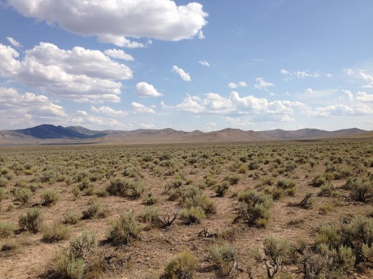
A warmer climate in North America causes drier steppes in California and an increase in rainfall in the eastern US.
Age(yrBP) | CO2(ppmv)
139617 | 196.5
138185 | 190.2
137293 | 194.3
136251 | 202.4
135603 | 198
134287 | 203.7
133427 | 210.6
132492 | 223.5
131329 | 245

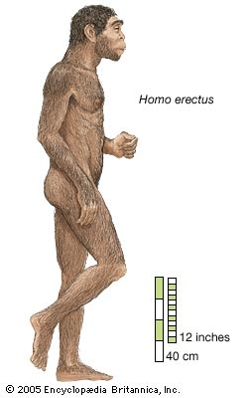

150,000- 140,000 Years Before Present
Homo erectus goes extinct 143,000 years ago. It is possible that a cold climate contributed to their extinction.
Age(yrBP) | CO2(ppmv)
149921 | 188.9
148831 | 203
145363 | 196.9
142058 | 190.4
140899 | 195.6
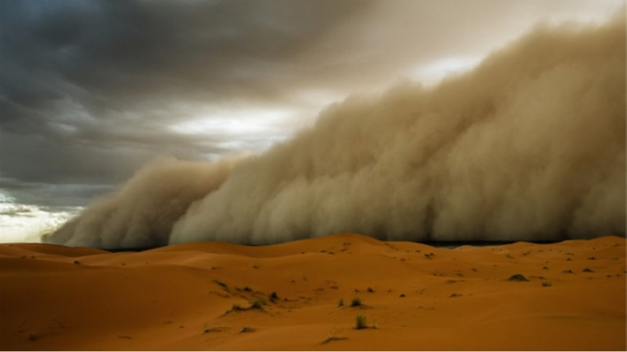
160,000- 150,000 Years Before Present
Dust storms blow dirt high into the atmosphere because the dense, cold air moving off of ice sheets causes severe wind.
Age(yrBP) | CO2(ppmv)
159943 | 196.5
159562 | 204.3
155813 | 187.5
155395 | 185.5
154480 | 189
151423 | 200.6

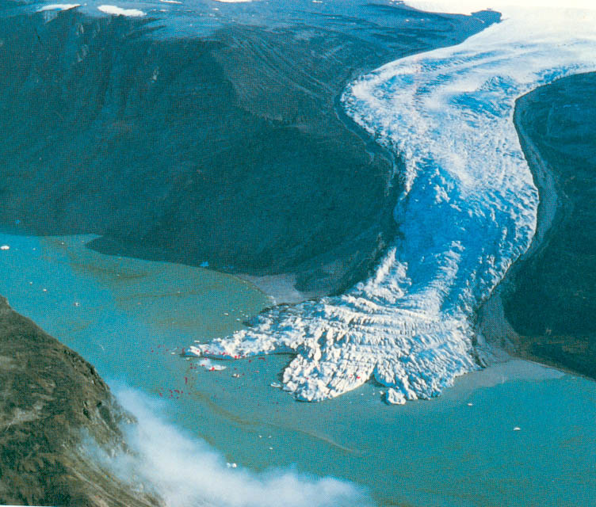
170,000- 160,000 Years Before Present

Age(yrBP) | CO2(ppmv)
169492 | 197.7
167183 | 197.8
164439 | 196.6
163698 | 183.8
162228 | 190.1
161679 | 191.6

Glaciers carve deep U-shaped valleys in mountains, and cover entire continents.

180,000- 170,000 Years Before Present

Age(yrBP) | CO2(ppmv)
179117 | 198.1
178179 | 217.7
177139 | 213.2
175306 | 207.7
173135 | 189.4
172434 | 190.3
171351 | 196

190,000- 180,000 Years Before Present
Age(yrBP) | CO2(ppmv)
189076 | 220.3
188436 | 231.4
186697 | 231.3
184685 | 210.7
182046 | 203.4
180068 | 199.7

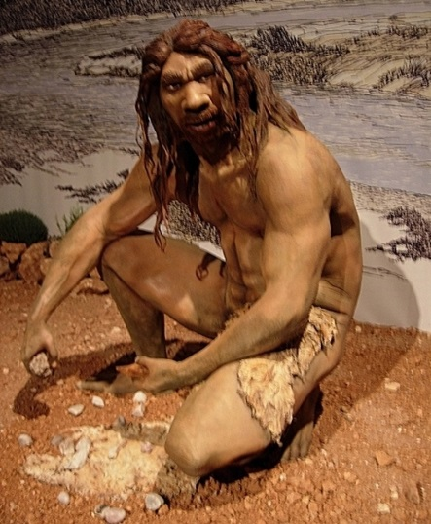
200,000- 190,000 Years Before Present

Age(yrBP) | CO2(ppmv)
199918 | 239.1
198972 | 250.9
196179 | 242.6
195017 | 226.4
193481 | 220
192910 | 226.5
190352 | 218
Homo heidelbergensis becomes extinct.

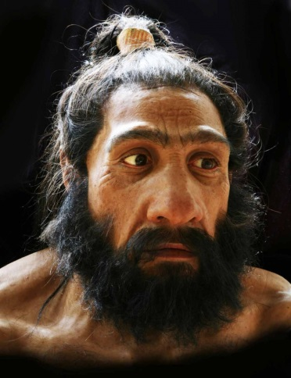
210,000- 200,000 Years Before Present
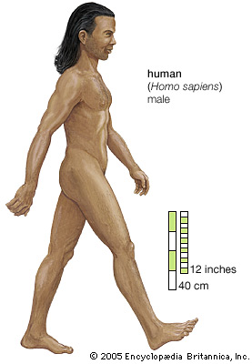
Homo sapiens (modern human) first appears on Earth.
Homo neanderthalensis first appears on Earth.
Age(yrBP) | CO2(ppmv)
209817 | 239.5
209432 | 246.9
208995 | 252
208064 | 244.6
207544 | 242.2
206810 | 230
205952 | 238.1
205362 | 231.4
204480 | 226.3
203837 | 228.6
202874 | 231.9
201163 | 247.6

220,000- 210,000 Years Before Present
Age(yrBP) | CO2(ppmv)
219116 | 216.1
218361 | 214.1
216352 | 240.5
215382 | 245.3
214794 | 251.1
213984 | 247.5
212716 | 241.4
211858 | 251.2
210813 | 243.4
210154 | 257.4

230,000- 220,000 Years Before Present

Age(yrBP) | CO2(ppmv)
229423 | 232.4
227776 | 224.5
227027 | 233.1
226711 | 234.5
225909 | 235.5
224923 | 215.7
224269 | 203.3
222030 | 205.6
220739 | 208.8
220058 | 207.1

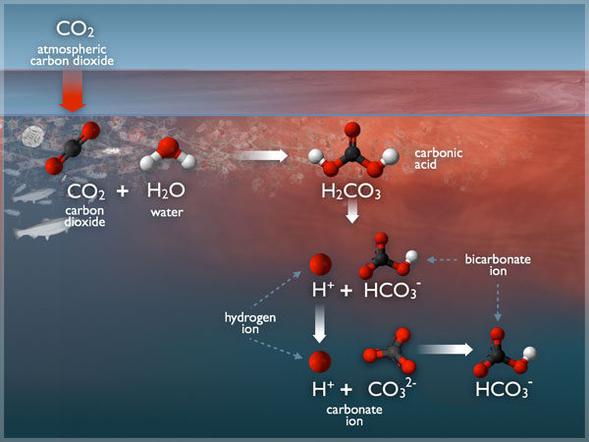
240,000- 230,000 Years Before Present
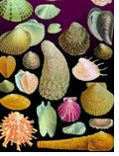
An increase in atmospheric carbon dioxide causes an increase in the acidity of the ocean. This dissolves shells of sea creatures, killing them.
Age(yrBP) | CO2(ppmv)
239973 | 252.8
239477 | 247.4
238558 | 245.6
237868 | 239.1
236734 | 247.4
236114 | 241.4
235480 | 252.1
234817 | 245.2
231066 | 241.6
230422 | 233.9

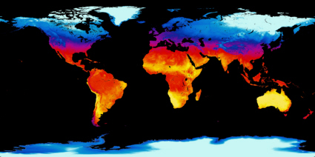
250,000- 240,000 Years Before Present
Temperatures rise as carbon dioxide levels rise. This causes sea levels to rise as well, flooding coastal areas around the world.
Age(yrBP) | CO2(ppmv)
247681 | 214.7
245441 | 219.4
244347 | 236.7
243856 | 249.9
242346 | 280.2
242007 | 279
241366 | 263.2
240945 | 259.7

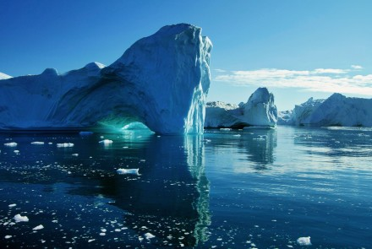
260,000- 250,000 Years Before Present
So much water is locked up in glacial ice that the sea level is over 120 meters (400 feet) LOWER than today, and much more land is exposed.
Age(yrBP) | CO2(ppmv)
258661 | 203.9
257100 | 204
256309 | 201.9
255498 | 199
253636 | 195.4
252739 | 196.7
251864 | 195.4
251005 | 213.9
250133 | 200.2

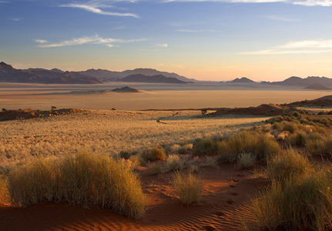
270,000- 260,000 Years Before Present
A cold climate reduces the amount of evaporation which leads to more arid (dry) conditions on much of the planet. Plants and animals evolve, migrate, or go extinct.
Age(yrBP) | CO2(ppmv)
269154 | 194.2
268181 | 187.2
267442 | 188.7
266326 | 211.7
265653 | 199.9
264509 | 228.1
262930 | 214.6
262092 | 208.9
260916 | 205.7
260353 | 209.6

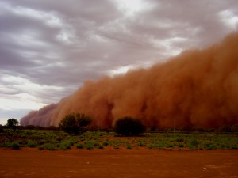
280,000- 270,000 Years Before Present
Dust storms blow dirt high into the atmosphere because the cold climate causes extreme wind at the edge of glaciers. Dust settles onto the Antarctic ice sheet.
Age(yrBP) | CO2(ppmv)
279320 | 211
278350 | 204.5
277361 | 202.2
276326 | 193.2
275350 | 198.4
274321 | 194.1
273310 | 193.9
272311 | 190.4
271256 | 184.7
270222 | 198.8

290,000- 280,000 Years Before Present

Age(yrBP) | CO2(ppmv)
288233 | 231
287538 | 230.4
287036 | 231.4
286128 | 226.4
285380 | 228
283785 | 231.3
281758 | 223.7
280269 | 215.3

300,000- 290,000 Years Before Present

Age(yrBP) | CO2(ppmv)
299621 | 231
298741 | 224.4
297921 | 217.1
295930 | 213.1
294568 | 212.7
293057 | 206
292405 | 207.6
291367 | 217.1
290153 | 234.9

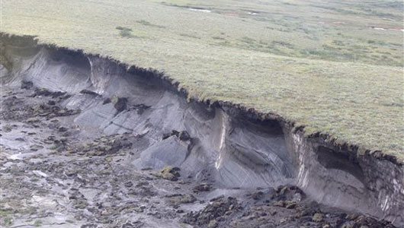
310,000- 300,000 Years Before Present
Age(yrBP) | CO2(ppmv)
309389 | 226.2
308744 | 227.8
307495 | 225.8
306547 | 244.8
305655 | 248.6
304901 | 250.2
304232 | 240.7
303226 | 240.2  Permafrost (soil that is permanently frozen in all seasons) melts, releasing carbon dioxide and methane into the atmosphere.
302280 | 236
301402 | 239
300472 | 236.1

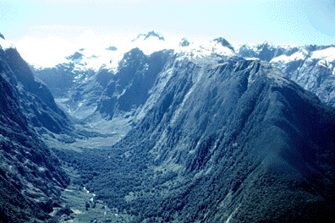
320,000- 310,000 Years Before Present

Age(yrBP) | CO2(ppmv)
319480 | 255.8
318559 | 233.4
317734 | 245.2
316897 | 251.6
316200 | 272.6
315572 | 246.8
314867 | 257.1
313414 | 251.6  Glaciers melt, leaving U-shaped valleys, cirque lakes, and moraines as evidence that they once covered the area.
312676 | 241.9
311868 | 239
310168 | 233.2

330,000- 320,000 Years Before Present

Age(yrBP) | CO2(ppmv)
329475 | 265
328221 | 275.1
327590 | 271.9
326972 | 270.1
325720 | 264
324971 | 266.2
323526 | 260.3
322767 | 260.4
320358 | 249.2

340,000- 330,000 Years Before Present
Age(yrBP) | CO2(ppmv)
339298 | 250.1
337391 | 234.2
336725 | 239.6
335918 | 241.9
334748 | 270.5
333890 | 285.8
333380 | 278.1
332919 | 298.6
332285 | 289.1
331438 | 273.1
330208 | 271.7

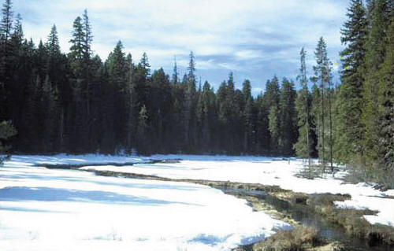
350,000- 340,000 Years Before Present

Age(yrBP) | CO2(ppmv)
349688 | 216.2
348298 | 221.1
345980 | 220.3
344446 | 211.9
343282 | 204.8
341802 | 205.2  Glaciers cover the Rocky Mountains. Boreal forests and glacial melt cover the Great Plains of North America creating rich, deep soils in what is now the “bread basket of the world.”
340456 | 200.7

360,000- 350,000 Years Before Present

Age(yrBP) | CO2(ppmv)
358712 | 185.8
356898 | 186.1
355302 | 193
352275 | 209.2
350925 | 209.4
As the oceans cool, the water can hold more dissolved gas, so the carbon dioxide moves out of the atmosphere into the ocean. This is a positive feedback, with less carbon dioxide causing less heat to be radiated back to the surface, cooling the planet faster.

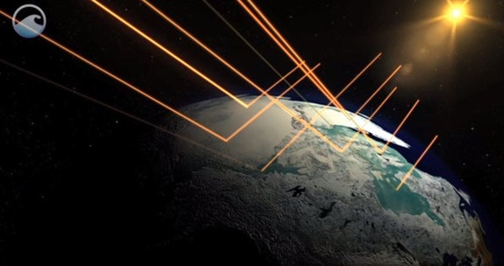

370,000- 360,000 Years Before Present
Age(yrBP) | CO2(ppmv)
369446 | 214.7
367856 | 199.9
366235 | 201.9
363385 | 206.3
360957 | 201.2  As the planet cools, positive feedback systems work to cool the planet faster. More snow on the ground (higher albedo) means more reflected light and less heat absorbed by the Earth.

380,000- 370,000 Years Before Present

Age(yrBP) | CO2(ppmv)
379696 | 239.1
378096 | 240
376568 | 227
372646 | 229.6
371090 | 224.6

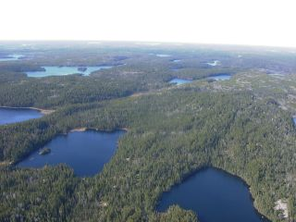

390,000- 380,000 Years Before Present

Age(yrBP) | CO2(ppmv)
389946 | 250.1
388062 | 255.2
386144 | 259.2
385398 | 264.6
384534 | 258.1
382670 | 245.8  Thousands of lakes remain where glaciers carved undrained depressions in the bedrock.
381132 | 246.8

400,000- 390,000 Years Before Present

Age(yrBP) | CO2(ppmv)
399722 | 277.1
398086 | 276.3
394560 | 260.7
393579 | 273.6
392544 | 259.5
391896 | 266.3

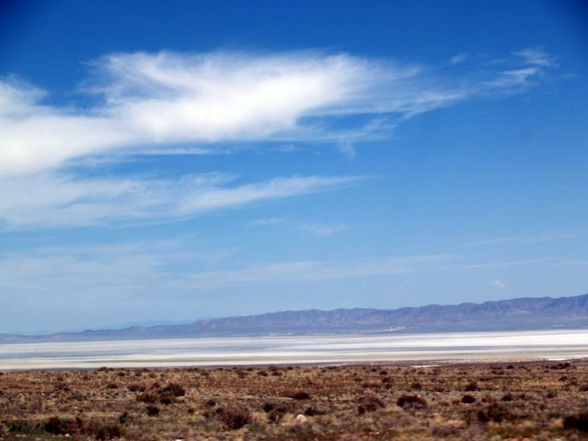
410,000- 400,000 Years Before Present
Age(yrBP) | CO2(ppmv)
409383 | 274.2
408600 | 284.5
407093 | 285.6
406368 | 279.6
404927 | 280.5
404181 | 276.5
402731 | 275.7
402000 | 283.1  Pluvial lakes dry up as ice sheets retreat, taking their runoff with them. The lakes no longer have a source of water.
400504 | 283.2

420,000- 410,000 Years Before Present

Age(yrBP) | CO2(ppmv)
419808 | 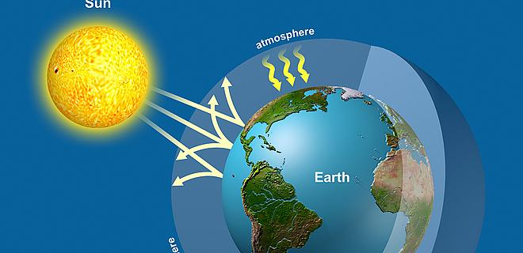  271.2  Global temperatures rise as carbon dioxide in the atmosphere radiates heat back to Earth.
419260 | 273.7
418245 | 274.6
417698 | 271.8
417191 | 273.4
416193 | 271.7
415717 | 276.4
414963 | 271.6
413948 | 264.9
412962 | 274.9
411071 | 283.5
410206 | 282.6

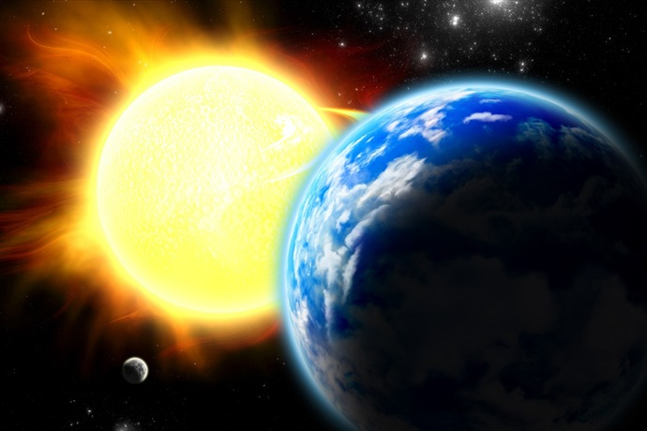
430,000- 420,000 Years Before Present

Age(yrBP) | CO2(ppmv)
429876 | 227.2
429006 | 219.7
427566 | 242.5
426598 | 252.1
425975 | 255.3
425242 | 270
424840 | 270.8
423764 | 267.7  The position of the sun relative to Earth changes and creates longer growing seasons in the Northern hemisphere. This causes snow and glaciers to melt, and oceans to release more CO₂ into the atmosphere as the water warms up.
422649 | 270.6
422074 | 266.4
421484 | 268.6
420350 | 273.8

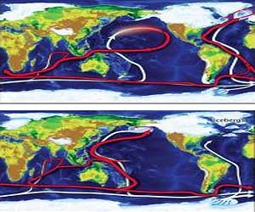
440,000- 430,000 Years Before Present

Age(yrBP) | CO2(ppmv)
439565 | 199.1
438356 | 202
437152 | 201.3
435989 | 201.7
434804 | 200.3
433674 | 207.5
432599 | 209.8  With ice covering much of the northern hemisphere, ocean currents most likely shifted, causing less warm water to flow near the poles, and adding to global cooling.
431445 | 207.6
431063 | 211.5

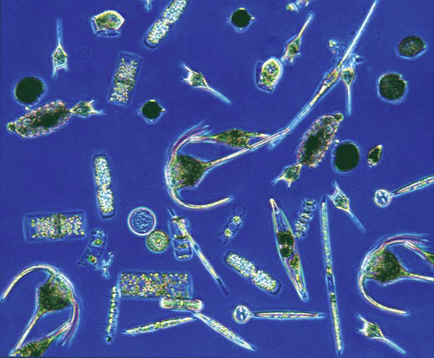

450,000- 440,000 Years Before Present

Age(yrBP) | CO2(ppmv)
449244 | 198.4
448103 | 201.9
446984 | 204.9
445829 | 201.2
444650 | 201.7  Added iron from dust in the atmosphere most likely provides nutrients for plankton to thrive in the oceans. Increased photosynthesis pulls CO₂ from the atmosphere.
443562 | 208.1
442411 | 203.5
441220 | 201.1
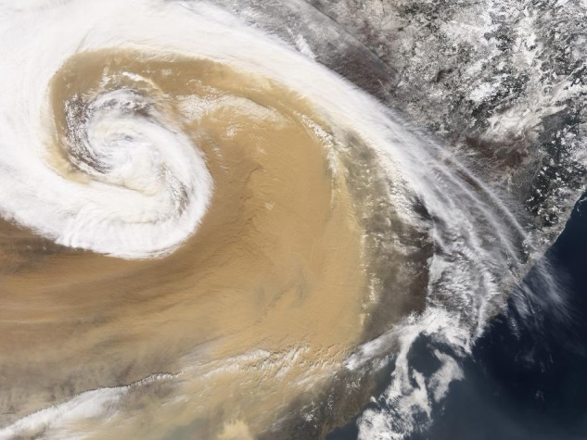
460,000- 450,000 Years Before Present

Age(yrBP) | CO2(ppmv)
459430 | 194.4
458049 | 190.7
456591 | 195.5
455279 | 202.4
454023 | 208.3
453514 | 203.3  Wind near the margins of glaciers is extreme. This leads to severe dust storms that carry dust high into the atmosphere, depositing it on different continents and in the oceans. Dust settles onto the Antarctic ice sheet, leaving a permanent record.
452795 | 204.3
452283 | 199.1
451593 | 192.5
450455 | 193.3

470,000- 460,000 Years Before Present
Age(yrBP) | CO2(ppmv)
469941 | 229.2
469470 | 218.7
468810 | 215.5
468323 | 206.5
467602 | 205.5
466265 | 203.4
464866 | 204.4
463456 | 208.1
462133 | 210
461687 | 205.2
460792 | 199.9

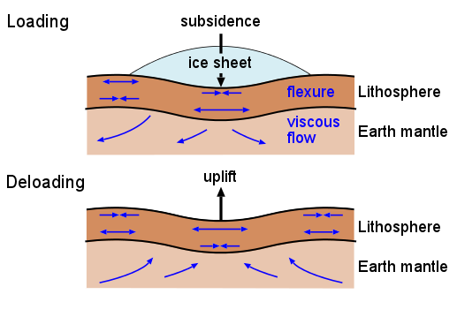
480,000- 470,000 Years Before Present

Age(yrBP) | CO2(ppmv)
479144 | 218.8
478721 | 220.8
478124 | 231.3
477162 | 239.1
476240 | 236.6
475218 | 232.8
474162 | 233.1
473102 | 241.2  Land in Canada and Russia most likely “rebounds” and rises hundreds of feet as the weight of ice sheets is removed. This is called isostatic adjustment.
472095 | 245.6
471046 | 243.7
470597 | 232.7

490,000- 480,000 Years Before Present

Age(yrBP) | CO2(ppmv)
489722 | 242.6
488996 | 252.8
488268 | 242
487541 | 237.1
486816 | 231.3
485276 | 233
484465 | 231.2
483649 | 231.4
482803 | 231.4
481932 | 227.3
480108 | 223.8

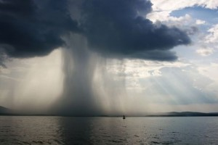
500,000- 490,000 Years Before Present

Age(yrBP) | CO2(ppmv)
499610 | 230.8
498104 | 232.8
497366 | 236.5
496608 | 236.4
495085 | 238.5
494311 | 238.3
494311 | 238.3
492738 | 239.7  Global temperatures rise as atmospheric carbon dioxide radiates heat back to Earth. Increased evaporation from the ocean causes more rain, and water vapor is another greenhouse gas, causing more warming.
491959 | 243.7
491191 | 246.7
490445 | 243.3

510,000- 500,000 Years Before Present

Age(yrBP) | CO2(ppmv)
509247 | 233.4
508476 | 240.3
507714 | 237
507011 | 238.2
506287 | 236
505516 | 235.5
504777 | 233.9
504083 | 234.1
503375 | 232.2
502625 | 232  As the oceans warm, carbon dioxide that was dissolved in the water is released into the atmosphere. The carbon dioxide then causes more warming.
501130 | 230.8
500363 | 228.2

520,000- 510,000 Years Before Present

Age(yrBP) | CO2(ppmv)
518965 | 243.5
517706 | 247.7
516417 | 245.5
515113 | 247.2
514429 | 243
513724 | 241.5
512997 | 239.2
512269 | 238.2
511515 | 242
510765 | 235.2
510008 | 236.4
530,000- 520,000 Years Before Present

Age(yrBP) | CO2(ppmv)
529640 | 204.4
528262 | 220.7
527454 | 220.3
526661 | 221.2
525164 | 224.7
524409 | 227.8
523666 | 230.3
522923 | 233.7
522216 | 235.8
521552 | 236.8
520892 | 241.9
540,000- 530,000 Years Before Present
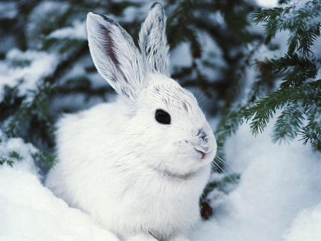
Age(yrBP) | CO2(ppmv)
538959 | 205
537770 | 211.2
536622 | 212.9
535483 | 206.4
534364 | 205
533246 | 199.4
532119 | 199.8
531662 | 190.5
531035 | 193.8  As carbon dioxide levels fall, less heat is radiated back to Earth by the molecules in the atmosphere. This causes global cooling.
530685 | 195.1
530016 | 200

550,000- 540,000 Years Before Present

Age(yrBP) | CO2(ppmv)
549830 | 219.9
548933 | 215.2
547972 | 213.6
547013 | 202.5
545956 | 204.6
544804 | 209.7
543676 | 209.6
542502 | 210.3
541345 | 208.1
540154 | 203.6
560,000- 550,000 Years Before Present
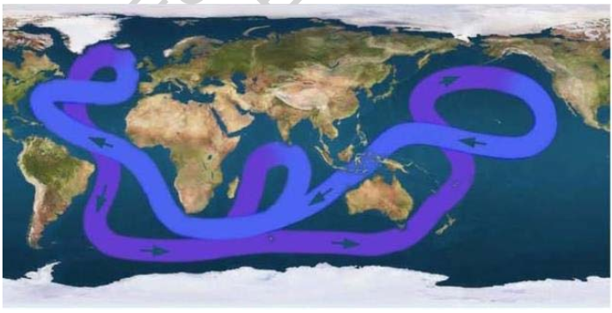
Age(yrBP) | CO2(ppmv)
559972 | 231.6
559461 | 228.3
558929 | 230.3
557385 | 238.1
556724 | 245.6
556364 | 250.5
556143 | 244
555839 | 249.1
554831 | 233.9  Ocean currents influence climate. Warm water from the equator travels to the poles, where it cools and sinks, creating a conveyor belt of water during warm periods on Earth.
553626 | 224.3
552250 | 220.3
551452 | 226.3
550637 | 221.7
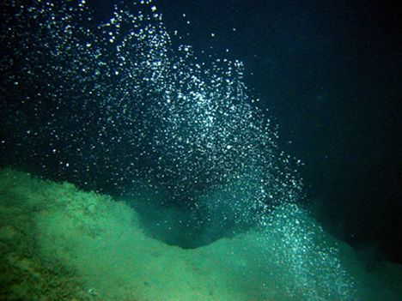
570,000- 560,000 Years Before Present

Age(yrBP) | CO2(ppmv)
569728 | 251.3
568167 | 253
567777 | 252.8
566619 | 254.5
565851 | 254.3
565466 | 253.7
564311 | 252.4
563517 | 247.6  As oceans warm, methane is released from the once-frozen ocean bottom. Since methane is a greenhouse gas, temperatures rise even more.
562690 | 245.7
561846 | 240.1
560930 | 234.6

580,000- 570,000 Years Before Present

Age(yrBP) | CO2(ppmv)
579821 | 244.1
578857 | 252.9
578305 | 249.1
577769 | 251.1
576723 | 251.3
575730 | 252.5
575265 | 248.9
574803 | 252.1
572190 | 246.3
571367 | 251.6
570139 | 251.8

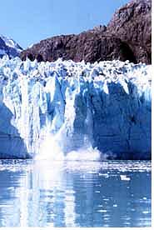
590,000- 580,000 Years Before Present

Age(yrBP) | CO2(ppmv)
589868 | 248.1
589224 | 250.2
588716 | 246.3
587647 | 234.4
586893 | 226
583413 | 210.6
583034 | 206.7
582000 | 215.4
581507 | 219.4
580695 | 230.3
580019 | 243.8  Glaciers melt, and sea levels rise 100 meters.

600,000-590,000 Years Before Present

Age(yrBP) | CO2(ppmv)
599434 | 229.4
598833 | 226
597966 | 219
597443 | 216.3
596515 | 216.4
595189 | 232.9
594639 | 238
593870 | 238.1
592697 | 229.4
592279 | 225.7
590335 | 243.6

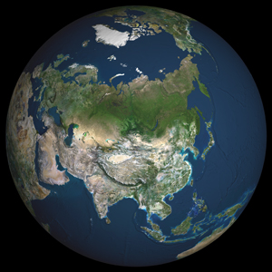

610,000- 600,000 Years Before Present

Age(yrBP) | CO2(ppmv)
608929 | 259.2
607708 | 254.6
606374 | 248.5
605076 | 244.5
603673 | 239.1  Warmer climates mean longer growing seasons, more land to settle on, and increases in plant and animal populations. Homo heidelbergensis expands to new territories.
602278 | 237.9
600882 | 232.5

620,000- 610,000 Years Before Present

Age(yrBP) | CO2(ppmv)
618955 | 247.9
617544 | 252.3
616227 | 252.4
614923 | 252.5
613709 | 256
612514 | 258
611319 | 259.6
610136 | 257.7

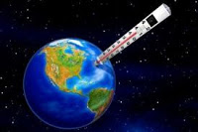
630,000- 620,000 Years Before Present

Age(yrBP) | CO2(ppmv)
629446 | 198.7
627999 | 205
627211 | 214.9
626215 | 227.8
625570 | 234.3
624690 | 237.3
623214 | 238.6  As global temperatures rise, positive feedback systems cause faster increases in temperature. Less snow and ice means more radiation from the sun is absorbed by dark soil. Warmer oceans release more carbon dioxide into the atmosphere, causing more heat to be radiated back to Earth.
621760 | 243
620338 | 245.4

640,000- 630,000 Years Before Present
Age(yrBP) | CO2(ppmv)
639848 | 187.7
638127 | 194.3
636957 | 193
635489 | 193.9
634592 | 192.1
632856 | 195.6
632001 | 199.5
630295 | 199.9

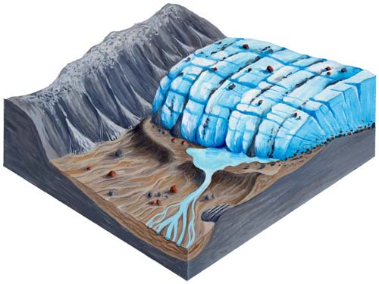
650,000- 640,000 Years Before Present

Age(yrBP) | CO2(ppmv)
649598 | 194.8
648946 | 192.1
647588 | 190.5
646723 | 188.6
645470 | 194.6
644662 | 194.1  Glaciers erode vast areas of continents under miles of ice and pile debris in moraines around the world.
643204 | 190.4
642405 | 190.2
640760 | 189.1

660,000- 650,000 Years Before Present
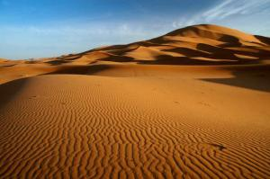
Age(yrBP) | CO2(ppmv)
659524 | 182.4
658474 | 189.2
657923 | 191.3
656882 | 198.7
656286 | 198.4
655202 | 193.2
654473 | 191.3
653448 | 185.3  Cool temperatures across the globe reduce precipitation. Arid regions expand, and deserts grow larger.
652802 | 185.8
651556 | 192
650891 | 187.8

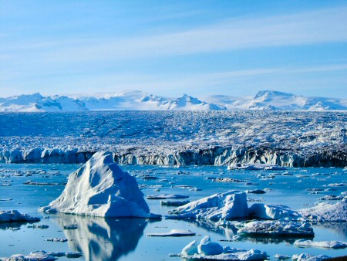
670,000- 660,000 Years Before Present
Age(yrBP) | CO2(ppmv)
669751 | 185.5
668447 | 175.6
667569 | 171.6
666995 | 172.7
665645 | 178.2
664690 | 185.8
664192 | 189.1
663206 | 189
662669 | 187.8
661650 | 189.8
660084 | 183.9  Ice sheets cover Antarctica, Canada, Russia, Northern Europe, and the weight starts to sink the crust to create the beginning of Hudson Bay.

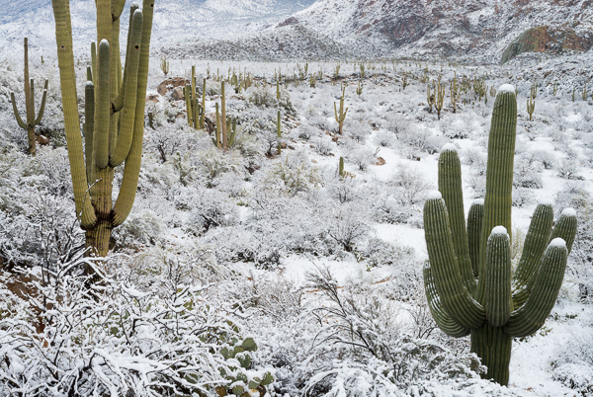
680,000- 670,000 Years Before Present

Age(yrBP) | CO2(ppmv)
679732 | 223
679252 | 230.3
678291 | 230
677380 | 217.4
677068 | 215.6
676524 | 214
676170 | 217.4
675589 | 220
674521 | 213.7  After millennia of warm temperatures, the planet begins to cool as the amount of solar radiation is reduced in the northern hemisphere, and carbon dioxide is absorbed into a cooling ocean.
673475 | 202.3
671926 | 192.5
671286 | 194.6
670176 | 189.3

690,000- 680,000 Years Before Present

Age(yrBP) | 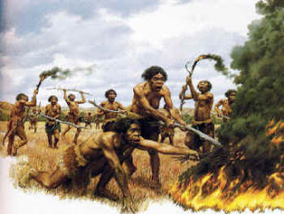  CO2(ppmv)  Homo heidelbergensis most likely develops speech and language.
689603 | 239.9
688881 | 234.9
688652 | 235.8
688195 | 233
687470 | 228.8
686726 | 227.3
685980 | 224.4
685217 | 219.7
684142 | 217.5
683262 | 218.7
682446 | 222.6
680920 | 216.2
680081 | 225

700,000- 690,000 Years Before Present
Age(yrBP) | CO2(ppmv)
699909 | 226
698880 | 226.4
698120 | 231
697331 | 232.4
696717 | 235.4
696062 | 234.6
695618 | 237.6
694941 | 236.9
692990 | 234.8
692765 | 232.9  Homo heidelbergensis first appears on Earth.
692057 | 235.5
691672 | 236.6
690999 | 234
690771 | 240
690057 | 235.6

710,000- 700,000 Years Before Present

Age(yrBP) | 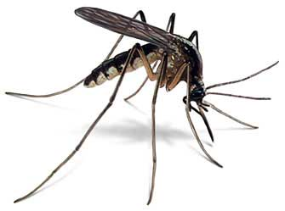  CO2(ppmv)  An interglacial period lasting millennia allows the migration and evolution of plants and animals on the planet. For example, malaria mosquitos likely move north to new habitats.
709680 | 219.7
706409 | 228.1
705410 | 228.5
704973 | 233.9
704211 | 231.2
703384 | 232.8
702381 | 230.3
701242 | 228.2
700744 | 227.6
700389 | 228.7

720,000- 710,000 Years Before Present
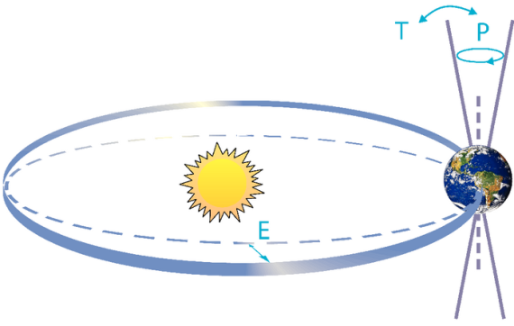
Age(yrBP) | CO2(ppmv)
719794 | 187.8
718779 | 184.3
718064 | 192.9
717065 | 205
716704 | 208.1
715750 | 222.1  It is likely that changes in the tilt of Earth’s axis allow more sunlight to fall on the northern hemisphere. This causes snow to melt, and seasons to be warmer. Less albedo means a positive feedback, increasing temperatures even more.
715180 | 217.7
714288 | 221.7
713843 | 222.3
712833 | 218.5
711104 | 218.9
710237 | 220.2

730,000- 720,000 Years Before Present

Age(yrBP) | CO2(ppmv)
728921 | 205.4
727192 | 204.5
726322 | 208.1
725059 | 206.3
724445 | 210.3
723464 | 213.2
723133 | 213.4
722039 | 211.3
721318 | 206.3
721318 | 206.3

740,000- 730,000 Years Before Present

Age(yrBP) | CO2(ppmv)
739842 | 185
738272 | 206.5
737266 | 211.3
737034 | 208.1
736460 | 209.7
735459 | 201.3
734604 | 207.4
733543 | 204.4
732548 | 205.9
731329 | 204.9
730299 | 204

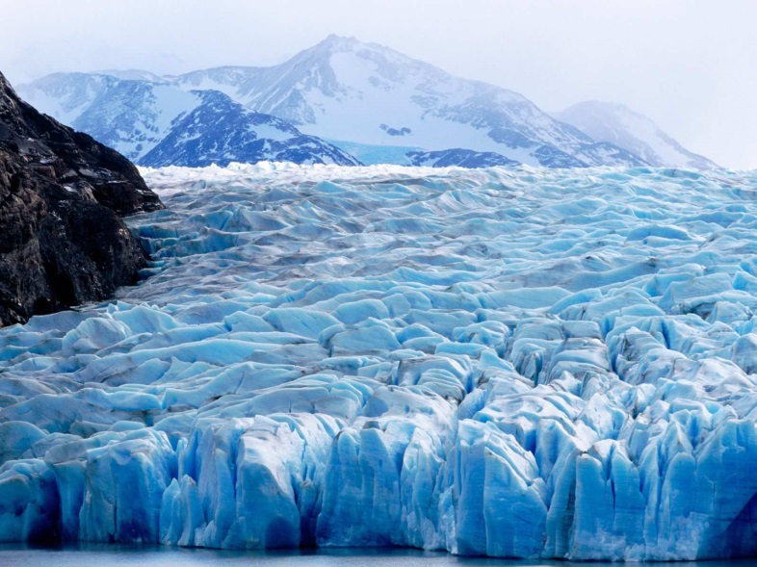
750,000- 740,000 Years Before Present

Age(yrBP) | CO2(ppmv)
749401 | 182.9
748913 | 181.4
748101 | 180.4
747110 | 180.8
746643 | 183.1
745836 | 180.2
744843 | 182
744354 | 181.2
743589 | 180.4
743233 | 181.7
742558 | 182.3  Glaciers cover much of the planet near the upper latitudes. Boreal forests grow in more southerly locations. There is less land available on which living things can grow.
742558 | 182.3
740277 | 178.9

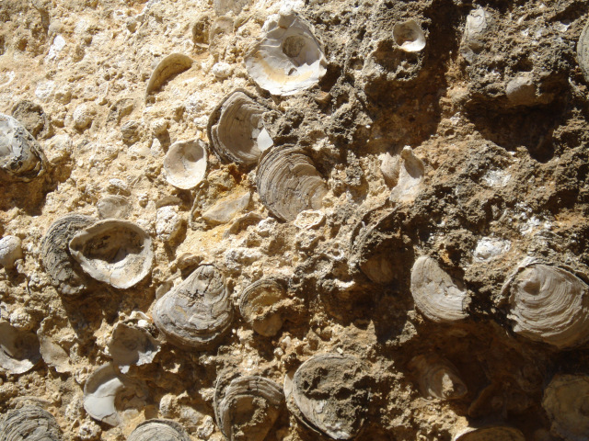
760,000- 750,000 Years Before Present

Age(yrBP) | CO2(ppmv)
759306 | 214.9
758883 | 217.9
758259 | 215.3
757962 | 219.2
757561 | 215
756871 | 210.7
755495 | 201.9
754394 | 195.8
753984 | 191.5
752978 | 196.5
752605 | 188  As carbon dioxide is absorbed into the ocean from the atmosphere, marine organisms convert the carbon into shells. The dead shells fall to the ocean floor and become limestone.
751830 | 190.1
750194 | 184.8

770,000- 760,000 Years Before Present

Age(yrBP) | CO2(ppmv)
769787 | 226
769514 | 228.1
769050 | 221.4
768655 | 222.4
767096 | 213.5
766110 | 215.7
764249 | 224.1
763934 | 221.4
763686 | 225.7
763319 | 215
762871 | 216
761453 | 206.1
760202 | 208.8

780,000- 770,000 Years Before Present
Age(yrBP) | CO2(ppmv)  Life on a warm planet tends to be easier to survive. There is more water, more food, and more temperate climates.
779364 | 243.9
778798 | 245.8
777556 | 246.3
776037 | 238.8
775051 | 240.5
773680 | 233.3
772076 | 230.9
771708 | 229.5
771260 | 237.7
770994 | 235.6
770724 | 238.2
770133 | 231.5

790,000- 780,000 Years Before Present
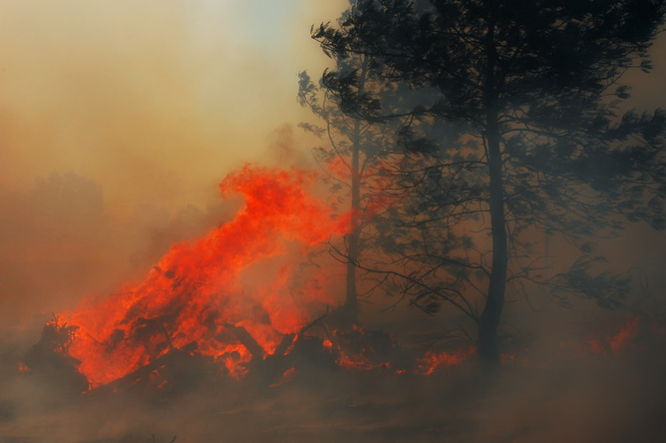
Age(yrBP) | CO2(ppmv)
789381 | 226.3
788887 | 229.5
788033 | 247.9
787076 | 256.9
786587 | 260.3
785789 | 255.4
784692 | 250.7
784147 | 246.9
783263 | 252.1
782059 | 246.2  Increased global temperatures increase the risk of fire and drought in mid latitudes. Higher global temperatures shift forest growth to northern latitudes.
781535 | 248.7
780612 | 242.8
780268 | 248.5

800,000- 790,000 Years Before Present
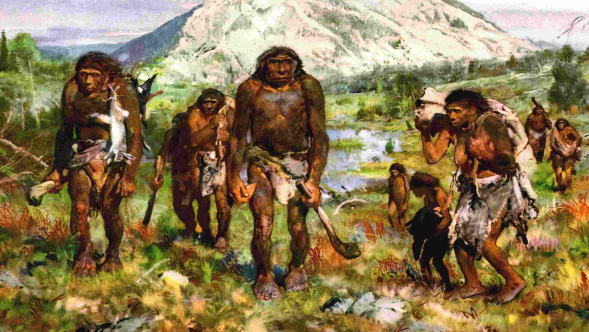
Age(yrBP) | CO2(ppmv)
798512 | 191
797099 | 188.4
794608 | 199.4
793260 | 209
792943 | 204
791491 | 215.4
790538 | 221.3
790153 | 218.2

Homo erectus changes from a vegetarian diet to include more meat. This allows for larger brain development with the increase in easily digestible calories in the diet.

