Earth’s Energy Budget
Rally Coach

Dr. Spencer Kagan has many publications and workshops on effective cooperative learning and higher-level thinking engagement strategies. The backbone of this activity can be further researched by reading his materials on “structures.”

Step 1 – A/B Partners – Decide which partner is “A” and which is “B.” Person A will talk first, and should be the more confident partner. Person B starts by holding the “magic pencil.” Start with the rally coach paper folded in half, with the Person A column showing.

Step 2 – Talk/Listen/Coach – Person A discusses their ideas for the answer to the first question. Person B listens. If person B agrees, they hand the pencil to person A, and person A writes their answer in the box. If person B disagrees, they “coach” person A on a solution without giving an answer. If neither knows and can’t figure it out, they raise their hand for teacher support.

Step 3 – Trade – Flip the paper over so that the Person B column is showing. Person A now holds the magic pencil, and Person B gives an answer. Person A becomes the coach, or hands over the pencil if the answer is correct.

Keep trading back and forth, flipping the paper over each turn. Some partnerships may take longer, and may not have time to finish the entire sheet. That is OK, as long as they are processing together, and coaching is taking place. They don’t necessarily have to finish the entire sheet.

Step 4 – Cut and save – At the end of the activity, cut the paper in half vertically, and have each person keep the half they wrote on. Alternatively, teachers could have the students write their names on the paper and hand it in so the teacher can evaluate understanding.

Earth’s Energy Budget
Rally Coach

Person A - name | Person B – name
1. What is the definition of a blackbody? | 1. Give an example of a blackbody and explain why it is a blackbody.
2. Look at diagram 1. Explain what F_{in} is. | 2. Look at diagram 1. Explain what F_{out} is.
3. Look at diagram 1. Explain why F_{in} must equal F_{out}. | 3. Look at diagram 1. What does sigma T⁴ mean? Where does this come from?
4. Look at diagram 2. What is albedo? | 4. Look at diagram 2. Give 3 examples of items on Earth that have an albedo effect.
5. Look at diagram 2. What percent of incoming radiation is absorbed by the Earth’s surface? Explain how you know. | 5. Look at diagram 3. Explain where 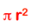 came from.
6. Look at diagram 4. Explain where  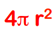came from. | 6. Look at diagram 5. What is the point of using all of this math? What does it ultimately tell us?

Diagram 1

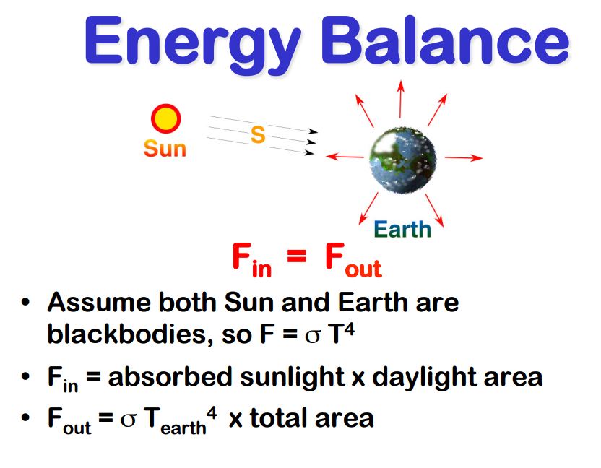

Diagram 2

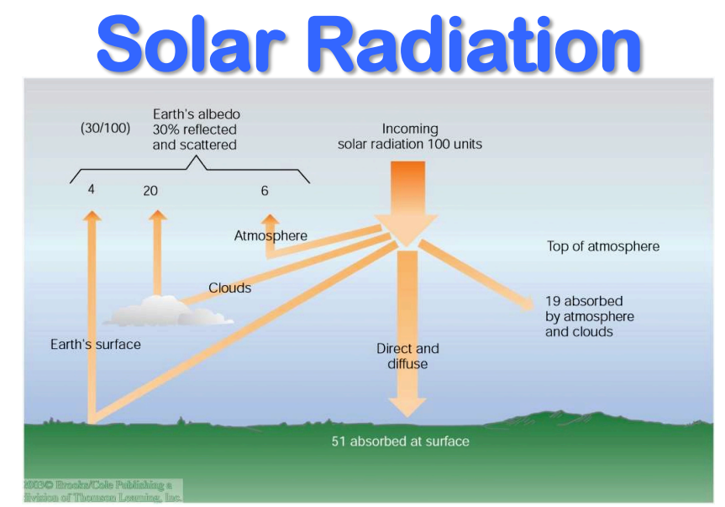

Diagram 3
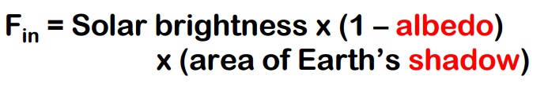
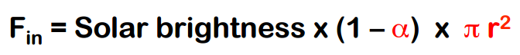

Diagram 4

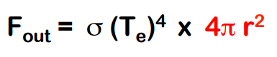

Diagram 5
