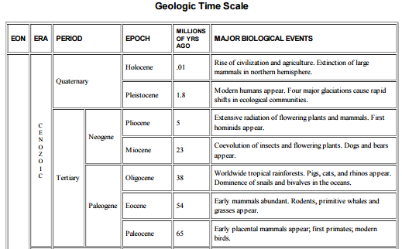

**Geologic events that impacted climate**

Rapid glacial cycles begin about 1 MYA

Drake Passage opens - Antarctic ice sheet

Antarctic thaw

40 MYA – India collides with Asia, raising Himalaya & Tibetan Plateau. Accelerated erosion consumes lots of CO2. Global cooling for 10’s of millions of years

56 MYA – Catastrophic release of methane causes huge CO2 spike, global warming, and mass extinction (“PETM”)

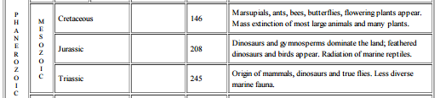

Huge asteroid impact in Caribbean causes years of frozen darkness … mass extinction including all dinosaurs (“KT boundary“)

90-120 MYA – No Atlantic Ocean; major mountain chain (Appalachian = Scottish Highlands = Norwegian Ranges) provides lots of fresh rock to be dissolved, consuming CO2

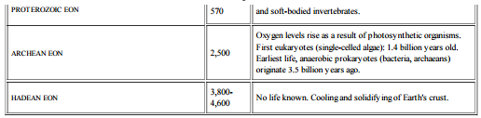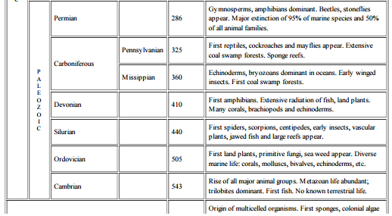

Oxygen from photosynthesis reacts with methane, dramatically reduces greenhouse effect. Snowball Earth episodes result!

300-500 MYA – Most continents “bunched up” at South Pole (“Gondwanaland”). Major Glacial Epoch with high albedo and cold climate worldwide