**Materials:**

* Seltzer maker (SodaStream or similar)
* Some tasty cheese
* Tap water
* Glasses or cups for drinking
* pH paper

Many people enjoy carbonated beverages, especially with food. The tiny bubbles and natural acidity of dissolved CO2 pairs well with creamy morsels, or as they say in Wisconsin, “it goes good with cheese!”

The chemistry of dissolved CO2 in water has also some surprising aspects that are important for understanding the global carbon cycle and its interactions with climate, especially over geologic time scales.

**What to do:**

Get some tap water and use the seltzer maker to bubble CO2 through some of it, but leave some of it flat. Taste both samples, paying attention to the feel of the water on your tongue as well as whether it tastes sweet, sour, salty, or bitter. Now eat a little bite of cheese and repeat the taste test.

Use the pH paper to estimate the pH of both the flat and sparkling water. What did you find?

Think about other “food pairings” like cheddar and apples, pizza and beer, or chardonnay and brie.

**Carbonate Equilibria:**

When CO2 dissolves in water, it forms carbonic acid by the reaction





The equilibrium in (1) can be expressed using Henry’s Law, as

 with 

where *pCO2* is the partial pressure of CO2 in the air. We can think of KH as the solubility of CO2 gas in water. Like many gases, CO2 is much more soluble in cold water than warm water. This is why soda or beer goes flat if it’s left on the table too long.

Carbonic acid is a weak acid, meaning that some of the molecules remain in the form shown in Eq (1), and some of them dissociate according to

 , .

The ion *HCO3-* on the right-hand-side of (3) is called “bicarbonate.” Bicarbonate can also dissociate in water by releasing another free proton to form carbonate ions according to

 ,  .

**When we taste sparkling water (or Coca-Cola or Ginger Ale), our tongues are tickled by the CO2 gas that comes out of solution in our warm mouths. Also, we taste the sour bite of the free protons (acidity) on the right-hand-sides of Equations (3) and (4).**

**Dissolved CO2 and Chemical Weathering of Rocks**

Chemistry students learn that pure water is neutral, with a pH of 7, but most natural water is a dilute solution of carbonic acid due to the presence of CO2 in the air. The pH of rain far from industrial pollution is 5.6 due to dissolved CO2 in the raindrops. The natural acidity of cloud droplets and raindrops is very important for the chemical reactions that dissolve mineral crystals in rocks.

Vegetated soils contain a lot of organic matter shed by plants. As microbes decompose this material, they convert a lot of it to CO2 by their respiration. The pore space of some soils has 100 times the partial pressure of CO2 that is present in ambient air, so soil solutions can be quite acidic. These acidic solutions make quick work of dissolving mineral grains in the underlying rock, forming yet more soil.

The chemical reactions between mineral crystals and carbonic acid are called chemical weathering. By dissolving soluble minerals like feldspar and micas, these reactions also free up less soluble mineral grains like quartz to be carried downstream (physical weathering).

Chemical weathering by carbonic acid from rain and soil moisture removes CO2 from the air over geologic time, which tends to cool the Earth’s climate. The more fresh rock is exposed by mountain building and other tectonic processes, the faster chemical weathering works. It’s also dependent on temperature, so the warmer the climate, the faster atmospheric CO2 gets depleted by chemical weathering processes. **Chemical weathering of rock by carbonic acid acts as a negative feedback, warming the climate when it gets cold and cooling the climate when it gets warm.**

**Dissolved CO2 in the Oceans**

Dissolved CO2 takes all three chemical forms: carbonic acid (H2CO3), bicarbonate ion (HCO3-) and carbonate ion (CO32-). The proportions of the various forms are determined by the pH of the water as shown in Fig 1 below. 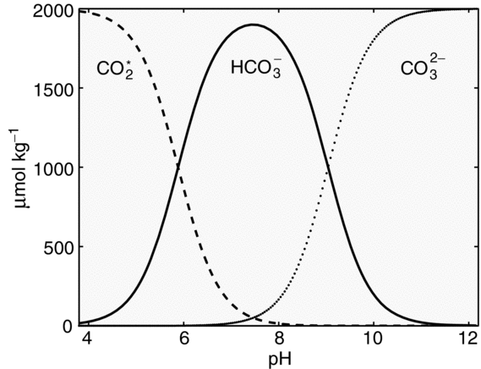

Figure 1: Concentration of three forms of dissolved inorganic carbon as a function of the pH of the solution

The average pH of the oceans is about 8.1, so the dominant form of dissolved inorganic carbon (DIC) in the oceans is the bicarbonate ion. This is very important for the Earth system because only the carbonic acid form (H2CO3, indicated in Fig 1 as CO2*) is in equilibrium with the CO2 gas in the atmosphere. The ocean can hold a huge amount of DIC this way, because in a sense it’s “hidden” from the atmosphere as bicarbonate, which doesn’t interact with the air at all. **If not for carbonate equilibria, atmospheric CO2 would be far higher and the Earth’s climate would be far warmer.**

The temperature dependence of CO2 is also really important to the oceans and the climate. CO2 is about twice as soluble in the water near Greenland and Antarctica as it is in the tropics. So the gas is taken up by the cold polar oceans and then transported at depth into the tropics, where it is emitted by the warm waters just like flat 7-Up. When climate cools, the oceans tend to take up more CO2 because it’s more soluble, amplifying the cooling. When the climate warms, the oceans tend to amplify the warming by going flat. **Exchanges of CO2 between the atmosphere and the ocean act as a positive feedback by amplifying changes in climate, both warming and cooling.**

**Ocean Acidification**

Many marine creatures build shells or skeletons from the molecule CaCO3, calcium carbonate. The accumulated skeletal debris of these creatures over millions of years is preserved in limestone. Nearly all limestone is of biological origin – very little is formed inorganically from chemical precipitation. But the biological reaction is the same, though metabolically driven. Calcareous organisms create their shells according to the reaction

 .

The solubility of calcium carbonate in the oceans is given by the solubility product



The calcium ions in seawater (part of the sea salt) are produced by chemical weathering of rocks on land. The carbonate ions are related to the exchange of CO2 between the atmosphere and oceans as described in Equations (1) through (4).

The relationship between dissolved CO2 and CaCO3 can be understood by simply dividing the dissociation constant in Eq (3) by the one in Eq (4). This gives

 .

By the rules of chemical equilibria, the ratio in equation (7) must always be true. This represents the reaction

 .

Equation (8) describes the overall process that occurs when a molecule of CO2 dissolves into seawater. One molecule of carbonic acid reacts with one carbonate ion to produce two bicarbonate ions. In other words, dissolving CO2 into the oceans consumes carbonate ions.

The consumption of carbonate ions in Eq (8) is directly proportional to the solubility of calcium carbonate described in Eq (6). In the simplest terms, **dissolving CO2 into the oceans makes the shells and skeletons of marine life more soluble! This process is called ocean acidification.**

In practice, seashells don’t just dissolve in the acidic ocean. Rather, marine life that makes calcareous shells have to use more metabolic energy (food) to form their shells, so they reproduce less and have a competitive disadvantage compared to species that don’t make calcareous shells.

Ocean acidification has already impacted the commercial oyster industry in the Pacific Northwest. If atmospheric CO2 reaches 600 to 800 ppm, substantial changes in the marine food web are expected throughout the world’s surface oceans. Left unchecked, ocean acidification will eventually dissolve lime muds at the bottom of the ocean worldwide. Paradoxically, this will replenish the carbonate concentration in the oceans and allow the CO2 from fossil fuel combustion to dissolve over geologic time. This is precisely the mechanism that allowed the climate system to re-equilibrate following the huge warming and acidification event 56 million years ago at the Paleocene-Eocene Thermal Maximum (PETM).