Directions for Concept Mapping

For background information, rationale, examples, and online concept mapping tools, please see “Kathy Schrock’s Guide To Everything” website at
http://www.schrockguide.net/concept-mapping.html
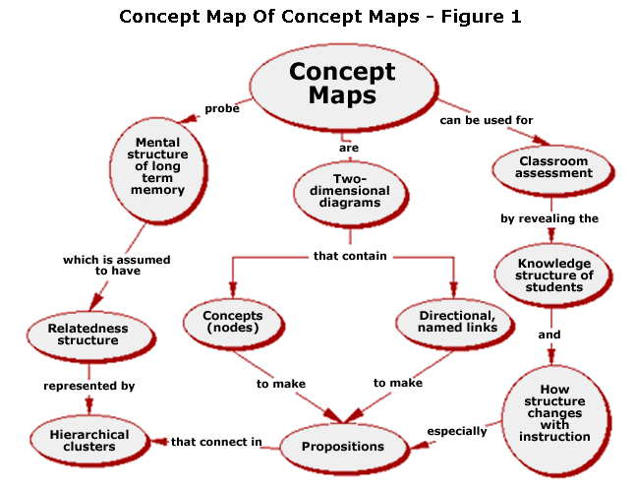

Concept map for “How Climate Works”
- Brainstorm with your team elements of a planetary climate system.
- Find main driving forces and create bubbles for each.
- Link under the main ideas examples and details that help explain how climate works.
- Link together the main ideas with connecting arrows and words.

Your team will create an initial map in the morning as a formative assessment, and revise the map after learning throughout the day as a summative assessment.

