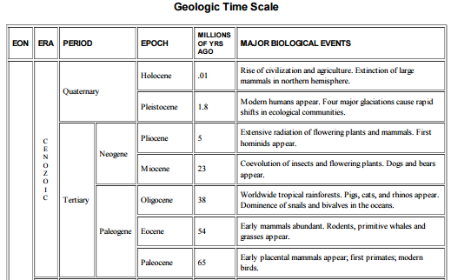

**Geologic events that impacted climate**

Rapid glacial cycles

Antarctic glaciation

Antarctic thaw

40 MYA – India collides with Asia

56 MYA - PETM

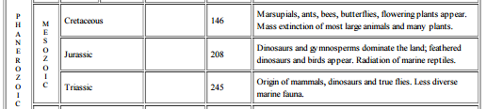

KT boundary -

90-120 MYA – No Atlantic Ocean;

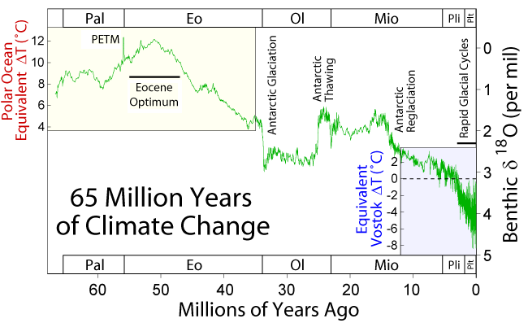

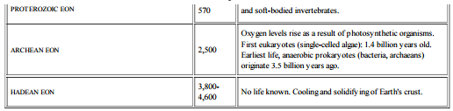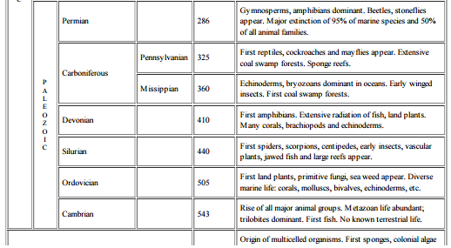

What are the major factors that have influenced climate over spans of millions of years? Give details.

1st Snowball Earth- CO2 removed from atmosphere as organic matter is buried;

300-500 MYA - Gondwana