- What are the two most common gases in the atmosphere? What percentage of the atmosphere’s molecules are made of each gas?
- About what fraction of the Earth’s surface is covered with oceans?
- How deep are the oceans, on average?
- Is there more water vapor in the lower atmosphere or the upper atmosphere? Is there more water vapor in the tropics or the polar regions?
- From which way does the wind blow in the Jet Stream? Which way does the wind blow from in the tropical Trade Winds?
- In the “middle latitudes” there are large areas of forest and other large areas of grassland. What climate variable mostly determines which is which?
- What are three ways to transfer heat energy from place to place?
- Which has shorter waves: near infrared or microwaves? Ultraviolet or X-rays?
- Which color of light has more energy per photon: blue or red?
- About what percentage of the Sun’s radiation is visible light?
- About what fraction of the Sun’s energy that hits the Earth is absorbed at the surface?
- What parts of the Earth have high albedo? What areas have low albedo?
- What is a “blackbody?”
- If the Kelvin temperature of a blackbody doubles, by what multiple does the rate of energy emitted by the blackbody increase?
- What is the greenhouse effect? (no more than 3 sentences)
- We discussed a “layer model” of the greenhouse effect in which visible light passes through glass to warm a dark surface. When extra glass layers are added, the surface warms up. Why?
- What’s the difference between “reflection” and “emission” of electromagnetic radiation?
- Use the difference between reflection and emission to explain surface albedo vs emission of thermal infrared radiation from the surface.
- What does surface albedo depend on? What does infrared emission from the Earth’s surface depend on?
- How do the Earth’s surface albedo and infrared emission affect climate?
- In the layer model of the greenhouse effect (with two layers of clear glass over a single slab of black glass), what happens to the visible radiation that enters the top of the stack?
- In the layer model of the greenhouse effect (with two layers of clear glass over a single slab of black glass), what happens to the thermal infrared radiation that is emitted by the black glass at the bottom of the stack? What outgoing radiation has to balance this incoming radiation?
- In the layer model of the greenhouse effect (with two layers of clear glass over a single slab of black glass), what two sources of radiation warm the bottom (black) slab of glass. What outgoing radiation has to balance this incoming radiation?
- In the layer model of the greenhouse effect (with two layers of clear glass over a single slab of black glass, what two sources of radiation warms the middle (lowest clear) slab of glass. What outgoing radiation has to balance this incoming radiation?
- In the layer model of the greenhouse effect (with two layers of clear glass over a single slab of black glass, what source of radiation warms the top (uppermost clear) slab of glass. What outgoing radiation has to balance this incoming radiation?
- In the layer model of the greenhouse effect (with two layers of clear glass over a single slab of black glass, briefly explain the incoming radiation that warms each slab and cools each slab of glass:
  - Bottom (black) slab of glass – incoming? Outgoing?
  - Middle (lowest clear) slab of glass – incoming? Outgoing?
  - Top (upperermost clear) slab of glass – incoming? Outgoing?
- Name two important “greenhouse gases.”
- What makes a gas a strong greenhouse gas?
- What makes the Earth’s atmosphere “selectively transparent” to different wavelengths of radiation? Over what broad range of wavelengths is the air transparent? Over what broad ranges of wavelengths is it more opaque?
- The outgoing infrared radiation above the atmosphere at 14 micron wavelength is about the same that would be emitted by a blackbody at 220 Kelvin (around -50 Celsius). Why?
- During the last Ice Age, the concentration of atmospheric CO2 was only about 200 parts per million (ppm). Now it’s about 400 ppm. This means the atmosphere absorbs 3.7 Watts m⁻² more outgoing radiation than it did then. At what concentration would it absorb an additional 3.7 Watts m⁻² compared to now?
- What force “holds the atmosphere up” against gravity?
- What makes air buoyant so that it rises?
- What is meant by the term “lapse rate?”
- Why does it take so much energy to evaporate water?
- If it takes 100 units of energy to warm 1 kg of water from the freezing point to the boiling point, how many units are required to evaporate 1 kg of water?
- Why does atmospheric temperature change more with height in clear dry air than it does inside of clouds?
- Under what conditions will rising air accelerate upward from the surface?
- Under what conditions will air that is lifted fall back down toward the surface?
- What is meant by “conditional stability” in the atmosphere?
- How is the lapse rate of the atmosphere related to the greenhouse effect?
- Will a stronger lapse rate promote a stronger or a weaker greenhouse effect?
- How does vertical mixing of the atmosphere reduce the strength of the greenhouse effect?
- What kinds of climate changes might enhance the vertical mixing of the atmosphere? What kinds of climate change might decrease the strength of vertical mixing of the atmosphere?
- How might changes in vertical mixing in the atmosphere amplify or reduce the strength of global warming over and above the direct effect of increased CO2?
- Below is a diagram of the overall vertical energy transfers between the Earth’s surface, the lower atmosphere, the upper atmosphere, and outer space. On the exam I will leave out a few of the numbers, and ask you to fill them back in. You don’t need to memorize the numbers! Instead, you can get them easily by knowing that energy is conserved at each layer.
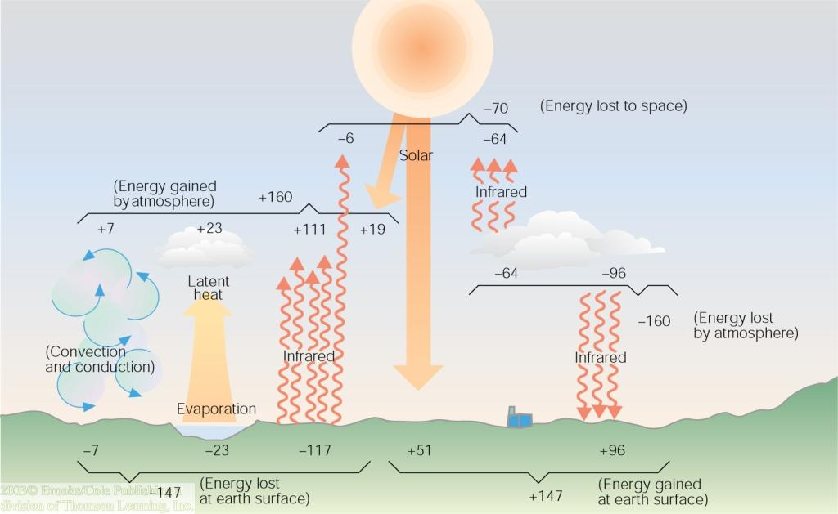
- The Earth’s surface absorbs about 174 Watts m⁻² of sunlight on the average, yet it emits about 400 Watts m⁻² of infrared radiation. How is this possible? How come emitting more IR than it receives in sunlight doesn’t make the surface colder and colder over time?
- What sources of energy warm the Earth’s surface?
- What sources of energy warm the Earth’s atmosphere?
- What parts of the Earth are warmed most strongly (and most weakly) by absorbed solar radiation?
- What parts of the Earth are cooled most strongly (and most weakly) by outgoing thermal (infrared) radiation?
- The Earth receives much more solar energy in the tropics than it loses through outgoing thermal radiation. What process keeps tropical temperatures from rising infinitely higher?
- What causes the seasons?
- Is the summer hottest when the Sun shines directly down on the surface? Why or why not?

