- What are the two most common gases in the atmosphere? What percentage of the atmosphere’s molecules are made of each gas?
- About what fraction of the Earth’s surface is covered with oceans?
- How deep are the oceans, on average?
- Is there more water vapor in the lower atmosphere or the upper atmosphere? Is there more water vapor in the tropics or the polar regions?
- From which way does the wind blow in the Jet Stream? Which way does the wind blow from in the tropical Trade Winds?
- In the “middle latitudes” there are large areas of forest and other large areas of grassland. What climate variable mostly determines which is which?
- What are three ways to transfer heat energy from place to place?
- Which has shorter waves: near infrared or microwaves? Ultraviolet or X-rays?
- Which color of light has more energy per photon: blue or red?
- About what percentage of the Sun’s radiation is visible light?
- About what fraction of the Sun’s energy that hits the Earth is absorbed at the surface?
- What parts of the Earth have high albedo? What areas have low albedo?
- What is a “blackbody?”
- If the Kelvin temperature of a blackbody doubles, by what multiple does the rate of energy emitted by the blackbody increase?
- What is the greenhouse effect? (no more than 3 sentences)
- We discussed a “layer model” of the greenhouse effect in which visible light passes through glass to warm a dark surface. When extra glass layers are added, the surface warms up. Why?
- What’s the difference between “reflection” and “emission” of electromagnetic radiation?
- Use the difference between reflection and emission to explain surface albedo vs emission of thermal infrared radiation from the surface.
- What does surface albedo depend on? What does infrared emission from the Earth’s surface depend on?
- How do the Earth’s surface albedo and infrared emission affect climate?
- In the layer model of the greenhouse effect (with two layers of clear glass over a single slab of black glass), what happens to the visible radiation that enters the top of the stack?
- In the layer model of the greenhouse effect (with two layers of clear glass over a single slab of black glass), what happens to the thermal infrared radiation that is emitted by the black glass at the bottom of the stack? What outgoing radiation has to balance this incoming radiation?
- In the layer model of the greenhouse effect (with two layers of clear glass over a single slab of black glass), what two sources of radiation warm the bottom (black) slab of glass. What outgoing radiation has to balance this incoming radiation?
- In the layer model of the greenhouse effect (with two layers of clear glass over a single slab of black glass, what two sources of radiation warms the middle (lowest clear) slab of glass. What outgoing radiation has to balance this incoming radiation?
- In the layer model of the greenhouse effect (with two layers of clear glass over a single slab of black glass, what source of radiation warms the top (uppermost clear) slab of glass. What outgoing radiation has to balance this incoming radiation?
- In the layer model of the greenhouse effect (with two layers of clear glass over a single slab of black glass, briefly explain the incoming radiation that warms each slab and cools each slab of glass:
  - Bottom (black) slab of glass – incoming? Outgoing?
  - Middle (lowest clear) slab of glass – incoming? Outgoing?
  - Top (upperermost clear) slab of glass – incoming? Outgoing?
- Name two important “greenhouse gases.”
- What makes a gas a strong greenhouse gas?
- What makes the Earth’s atmosphere “selectively transparent” to different wavelengths of radiation? Over what broad range of wavelengths is the air transparent? Over what broad ranges of wavelengths is it more opaque?
- The outgoing infrared radiation above the atmosphere at 14 micron wavelength is about the same that would be emitted by a blackbody at 220 Kelvin (around -50 Celsius). Why?
- During the last Ice Age, the concentration of atmospheric CO2 was only about 200 parts per million (ppm). Now it’s about 400 ppm. This means the atmosphere absorbs 3.7 Watts m⁻² more outgoing radiation than it did then. At what concentration would it absorb an additional 3.7 Watts m⁻² compared to now?
- What force “holds the atmosphere up” against gravity?
- What makes air buoyant so that it rises?
- What is meant by the term “lapse rate?”
- Why does it take so much energy to evaporate water?
- If it takes 100 units of energy to warm 1 kg of water from the freezing point to the boiling point, how many units are required to evaporate 1 kg of water?
- Why does atmospheric temperature change more with height in clear dry air than it does inside of clouds?
- Under what conditions will rising air accelerate upward from the surface?
- Under what conditions will air that is lifted fall back down toward the surface?
- What is meant by “conditional stability” in the atmosphere?
- How is the lapse rate of the atmosphere related to the greenhouse effect?
- Will a stronger lapse rate promote a stronger or a weaker greenhouse effect?
- How does vertical mixing of the atmosphere reduce the strength of the greenhouse effect?
- What kinds of climate changes might enhance the vertical mixing of the atmosphere? What kinds of climate change might decrease the strength of vertical mixing of the atmosphere?
- How might changes in vertical mixing in the atmosphere amplify or reduce the strength of global warming over and above the direct effect of increased CO2?
- Below is a diagram of the overall vertical energy transfers between the Earth’s surface, the lower atmosphere, the upper atmosphere, and outer space. On the exam I will leave out a few of the numbers, and ask you to fill them back in. You don’t need to memorize the numbers! Instead, you can get them easily by knowing that energy is conserved at each layer.
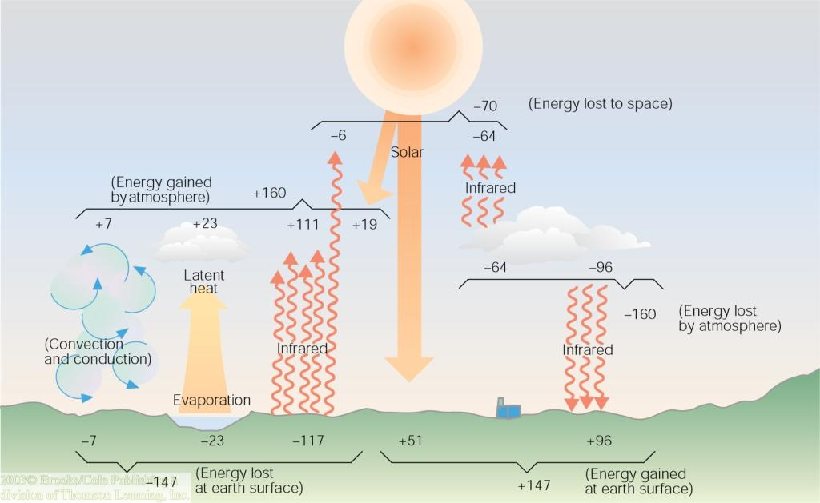
- The Earth’s surface absorbs about 174 Watts m⁻² of sunlight on the average, yet it emits about 400 Watts m⁻² of infrared radiation. How is this possible? How come emitting more IR than it receives in sunlight doesn’t make the surface colder and colder over time?
- What sources of energy warm the Earth’s surface?
- What sources of energy warm the Earth’s atmosphere?
- What parts of the Earth are warmed most strongly (and most weakly) by absorbed solar radiation?
- What parts of the Earth are cooled most strongly (and most weakly) by outgoing thermal (infrared) radiation?
- The Earth receives much more solar energy in the tropics than it loses through outgoing thermal radiation. What process keeps tropical temperatures from rising infinitely higher?
- What causes the seasons?
- Is the summer hottest when the Sun shines directly down on the surface? Why or why not?
- What is meant by the term “climate forcing?” How is it related to climate “response?”
- Name two processes that can change the total amount of absorbed solar radiation.
- Name two processes that can change the amount of outgoing longwave radiation from the Earth.
- Name two processes that cause positive climate forcing.
- Name two processes that can cause negative climate forcing.
- What is meant by “climate sensitivity” to radiative forcing?
- How much radiative forcing (in W m⁻²) do we expect for each doubling of atmospheric CO₂?
- What is climate feedback? Give an example of a positive and a negative climate feedback
- Without climate feedback, how much global warming would be expected for each doubling of atmospheric CO2?
- Including climate feedback processes, how much global warming is expected for each doubling of CO2?
- What are two different ways to estimate the sensitivity of the Earth’s climate to CO2? Do estimates of climate sensitivity derived by different methods agree or disagree with one another?
- Have there always been polar ice caps on Earth?
- Name three things that caused the Earth’s climate to change a lot over geologic time.
- How does plate tectonics and continental drift cause climate change over very long periods of time?
- Briefly explain how the following influence the climate, and over what time spans:
  - CO₂ released as volcanic gases
  - Chemical weathering of rocks on land
  - Stratospheric particles released from volcanoes
  - Continents at the Earth’s poles vs in the tropics
- When and why did the dinosaurs go extinct, and what does that have to do with climate?
- Over the 65 million years since the extinction of the dinosaurs, has the Earth’s climate slowly warmed or slowly cooled? Why?
- What is an Ice Age, and when was the Last Glacial Maximum?
- How many Ice Ages has the world experienced in the past 10 million years?
- How often do ice ages occur? What influences the timing of the ice ages?
- Name three kinds of periodic change in the Earth’s orbit around the Sun which are thought to influence the timing of Ice Ages.
- The total amount of solar radiation received by the Earth hardly changes at all during Milankovitch cycles. What single characteristic of Earth’s energy distribution (determined by orbital changes) is thought to be the most important in setting the timing of Ice Ages?
- When was the last major interglacial period?
- When the ice was melting after the last ice age, there was an event that caused the climate to rapidly cool again (about 13,000 years ago). What happened at that time to cool the climate?
- What is meant by the “Holocene climatic optimum,” and when did that occur?
- When was the Medieval Warm Period? Was it warmer than today?
- When was the Little Ice Age? Why did it occur? How do we know?
- How has climate changed in the past 150 years?
- Name three kinds of changes to the radiative forcing of the Earth’s climate that have been documented over the past 1000 years
- Compare the strength (in Watts per square meter) of three kinds of radiative forcing of the Earth’s climate over the past 1000 years
- Comparing the current climate to that of the Last Glacial Maximum 18,000 years ago, what is the radiative forcing due to differences in albedo and atmospheric CO2? What is the difference in global temperature? How can these numbers be used to estimate climate sensitivity to radiative forcing?
- How do we know the amount of CO₂ in Earth’s atmosphere during past ice ages?
- How do we know the change in albedo associated with glacial to interglacial transitions?
- How do we estimate the global mean temperature during the last ice age?
- How are the fossil fuel “emission scenarios” used in climate models generated? Are they actual predictions? How are they used?
- Under a high emission scenario, how much CO2 will be emitted by fossil fuel burning in 2100? How much will be emitted under a low growth scenario?
- What are three separate variables that show substantial climate change over the past 30 years.
- What is the difference between an empirical model and a deterministic model?
- Name three major components of a modern global climate model. What do modern climate models predict well? What don’t they include?
- Name a climate phenomenon that global climate models predicted long before it was observed.
- How are climate projections made for the 21st Century (what steps are taken to produce the maps of projected changes)?
- Given scenarios of future fossil fuel emissions, how much CO2 is expected to be in the atmosphere in 2100? How many Watts per square meter of radiative forcing would these ranges of CO2 produce?
- What are “representative concentration pathways” used by the IPCC?
What do their numbers (2.6, 4.5, etc) mean? Where do they come from?
- Depending on emission scenarios, what is our current best estimate of the average amount of global warming by 2100?
- Where in the world is warming likely to be strongest? Where is it likely to be weakest?
- Is Colorado expected to warm by about the same amount as the global average? If not, why not?
- Explain why a small change in the average summer temperature is likely to cause a large change in the frequency of extremely hot days.
- How do natural plants and animals adapt to a changing climate? Why does the rate of climate change matter so much for natural ecosystems?
- As the Earth’s climate warms, what must happen to global average precipitation?
- Over what regions is precipitation likely to increase in a warmer world? Over what regions is the precipitation likely to decrease?
- Describe likely changes in temperature and water availability over the central USA in the late 20th Century, as projected by climate models. What are the main sources of uncertainty in these projections?
- Explain how drought might become more of a problem in our region under a warmer climate even if there is no change in precipitation.
- How much is the sea level expected to rise in the 21st Century? Why is this difficult to estimate?
- In the geologic past, sea level rose and fell by tens of meters each time global average temperatures changed by a few degrees, but IPCC projections of sea level rise are much smaller for the 21st Century. Why?
- Name three reasons why we expect more wildfires under a warmer climate in the Rocky Mountain region.
- In what regions of the world is climate change likely to increase crop yields? In what regions are crop yields likely to decrease?
- What is meant by the term “storm surge?” Why is this likely to get worse in a warmer climate?
- If fossil fuel emissions were to completely stop, what would happen to the extra CO2 in the atmosphere? Where would it go?
- How long would it take for the CO2 to come halfway back down to preindustrial levels? How long would it take to come all the way down to preindustrial levels?
- Under a high emission scenario in which China and India industrialize their economies using coal as a major source of energy, for how long will the temperature remain more than 3 Celsius above current temperature?
- If global temperatures reach 3 Celsius above preindustrial levels for thousands of years, how much is sea level likely to rise? How do you know?
- Name two ways that CO2 dissolved in seawater can be transported to the deep ocean.
- What is ocean acidification, and why is it a problem?
- How do plants on land take up carbon dioxide form the air, and what keeps them from absorbing all the excess CO2 from fossil fuel burning?
- Name three processes by which the total amount of carbon stored on land can increase over a period of decades.
- What is the “Kaya Identity,” and how is it used to estimate future emissions of CO2?
- What are the main reasons for the rapid increase in fossil fuel emissions that is likely in the next 20-30 years?
- What is “hydraulic fracturing?” Write down one way that hydraulic fracturing might lead to less climate change, and one way it might lead to more climate change.
- What is meant by the terms “Stabilization Triangle” and “Stabilization Wedges” as explained by Pacala and Socolow?
- Using the “Climate Wedges” concept, give five examples of feasible strategies to avoid 1 billion tons of carbon emissions per year in 2065. Be as specific as you can (for example, “make 16 billion dilithium crystals” … just kidding!)
- Choose any 4 wedges you like from the 15 described by Pacala and Socolow, and list one advantage and one disadvantage for each one.
- Explain how the logarithmic dependence of warming on CO₂ makes each subsequent climate mitigation wedge more powerful than the previous wedge.
- By what percentage has the price of photovoltaic panels changed since 2011?
- Rank the following emission reductions technologies from cheapest to most expensive: (a) fuel efficient cars; (b) avoiding deforestation in Southeast Asia; (c) carbon capture & sequestration (CCS); (d) building insulation.
- What is meant by “concentrating solar power,” and what is the advantage of this technology relative to photovoltaic panels?
- What is the electric grid?
- What is meant by baseload and peaking power on the grid?
- Why is it challenging to accommodate large amounts of wind and solar generation on the current electrical grid?
- What is the “duck curve” for electrical power demand, and how does it demonstrate the challenges of grid integration of renewable power?
- What changes to electrical power distribution have been proposed to make the electrical grid more resilient to intermittent sources of electricity?
- Do you think climate change due to rising CO2 is likely to be a problem in your lifetime? How might your own life be affected?
- To what degree can future damages to the economy from climate change be avoided by adopting a “simpler lifestyle” (for example by riding your bike or growing a garden)?

