Spring 2016: ESS 543 (2 credits, CRN 25497)

Current Topics in Climate Change

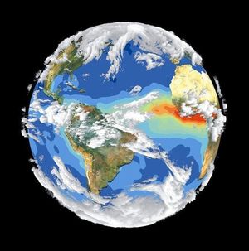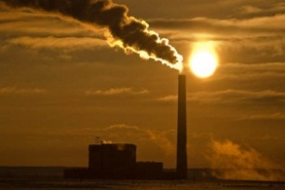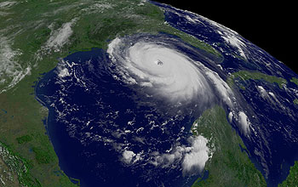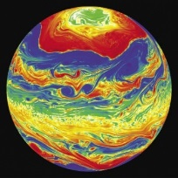

What is it about?
In this course, students will learn about current topics and climate fundamentals. Over the cou8rse of the semester students will teach each other about climate change science, climate change impacts, and climate change solutions. The goal is to help you understand the science behind the headlines.

When will it take place?
Spring 2016 term: Tuesdays and Thursdays from 11:00-11:50 am in room 301B Chemistry Building

Who are the instructors?
Dr. Rich Conant Dr. Scott Denning
Dept. of Ecosystem Science & Sustainability Dept. of Atmospheric Science
B229 Natural & Environmental Science Bldg. 224 Atmospheric Science, West
Tel. (970) 491-1919 Tel. (970) 491-8359
Email: rich.conant@colostate.edu Email: scott.denning@colostate.edu

Please don’t hesitate to contact the instructors to learn more about this course!

