ATS 760 Global Carbon Cycle

Assignment #3 Due Thursday November 9

“Reduced Organic-Matter Transformations” (ROT)

Consider a four-box model of terrestrial ecosystems as shown below:

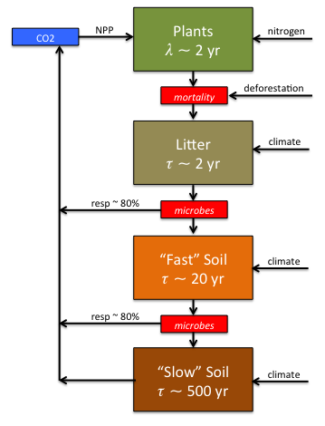
Photosynthesis converts CO₂ to plants, and is limited by nitrogen and other nutrients.

Plant mortality (death) converts plant carbon to “litter,” which is slowly decomposed by microbes. Let the average lifetime of the plants be λ = 2 years, and the average “turnover time” of the dead litter be  = 2 years.

ε=80% of the litter carbon eaten by the microbes gets turned back into CO2. The other (1- ε)=20% of the litter eaten by the microbes turns into “fast soil” (a.k.a. microbe poop).

Fast soil is decomposed more slowly by other microbes, converting this carbon back to CO2 with a respiration efficiency is also ε  80% with a turnover time of  = 20 years 

The remaining (1- ε)=20% is converted into nearly indigestible “slow soil” carbon that even microbes don’t want to eat. It is often bound physically and chemically to clay particles in the soil, where it decomposes very slowly with a turnover time of τ = 500 years.

Please see the Toy Model called “Terrestrial Carbon Cycle” on the class website for examples, and to test your model. You are basically going to build the model from the website yourself.

Please ask me for help with this assignment. It’s quite a bit of work to do all this, but it’s worth it! I will do homework help sessions every Friday afternoon in my office at 1 PM.

Assignment:
- Write a system of coupled ordinary differential equations describing the evolution of SOM in the PLANT, LITTER, FAST, and SLOW pools. Use the variables P, L, F, and S to denote these quantities (in Gt C). You will have four prognostic equations (one for each predicted variable).
Also, write diagnostic expressions for Net Primary Productivity (NPP), Total Respiration (RESP), and Net Ecosystem Exchange (NEE or CO₂ flux to the atmosphere), in Gt C yr⁻¹. These will not be differential equations, but rather will be simple algebraic formulas using current values of the prognostic variables.
- Discretize your model. Write down the algebraic equations you will use to approximate the ordinary differential equations in part 1. Justify your choice of time differencing scheme.
- A steady-state (equilibrium) solution can also be found analytically, by simply setting the time derivatives to zero and solving the resulting algebraic system. Solve for this steady state to calculate the amount of carbon in each pool when the biosphere is in equilibrium. As in Homework 1, adjust your model to produce a PLANT pool of 500 GtC and annual NPP of 60 GtC yr⁻¹.
- Write a short computer program to represent the equations you derived in problem 2. Initialize your program using the steady-state solution you derived in problem 3.
Download the file homework3.data.txt from the class website. This file lists hypothetical atmospheric CO₂, nutrient status, deforestation, and temperatures for each year from 1800 to 2300. You will use this file as input for problems 5, 6, and 7.
- Add CO₂ Fertilization: Modify your program so that the growth rate of the plants responds to the atmospheric CO₂ according to
.
Let β=0.36. Run your model from equilibrium in 1800 to 2300 using the CO2 data provided. Make graphs of the NPP, RESP, and NEE from 1800 to 2300.

- Add N Fertilization: Modify your program so that the carrying capacity increases in proportion to the “nutrient status” provided. Again, graph the changes in NPP, RESP, and NEE over the period 1800 – 2300.
- Add Deforestation: Add the provided deforestation rate to your plant mortality each year. Subtract half that amount from the total plant “carrying capacity” (equilibrium plant pool) to reflect semi-permanent conversion of forest to farms and pastures. Plot the NPP, RESP, and NEE that result.
- Add the effect of climate change. Adjust all the respiration terms so that rates of microbial respiration double for each increase of 10 C. This is typically written as
where Q₁₀ = 2. Plot NPP, RESP, and NEE from 1800 to 2300.

Please hand in your pencil-and-paper derivations for questions 1 – 3, printouts of your model code and graphs for the rest of the questions.

