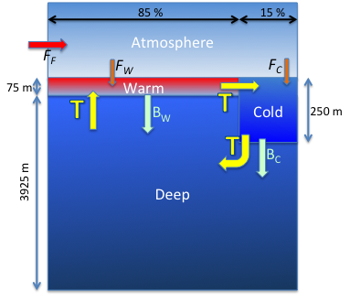
Consider the ocean as being made up of three well-mixed boxes: a “warm surface” box at low latitudes, a “cold surface” box at the highest latitudes of both hemispheres, and a “deep” box isolated from contact with the atmosphere. Above the ocean is a single well-mixed atmosphere with a mean surface pressure of 101325 Pascals. The atmosphere receives CO₂ from fossil fuel (F_{F}), which is assumed to instantly mix with the whole mass of the atmosphere. The surface boxes exchange CO₂ (F_{W} and F_{C}) with the atmosphere but the deep box only interacts with the surface boxes and does not exchange CO₂ with the atmosphere.
Let there be a slow thermohaline overturning circulation T = 20 Sv and let there be a constant net downward biological carbon flux (B_{W} and B_{C}) from each surface box that represents sinking organic particles.
Assume that the ocean covers 70% of the Earth’s surface, and that 85% of the ocean surface is “warm” while 15% of the ocean surface is “cold.” Let the warm ocean have a temperature of 21.5 °C with a mean wind speed of 5 m s⁻¹ and the cold ocean have a temperature of 1.5 °C with a mean wind speed of 12 m s⁻¹. Assume that the ocean is 4000 m deep, that the warm surface layer is 75m deep, and that the cold surface layer is 250 m deep.
Initialize the model for preindustrial conditions as we did in homework #3, with salinity = 34.78‰, pCO₂ = 278 ppm, average surface DIC = 2002 mmol kg⁻¹ and average Titration Alkalinity = 2311 mmol kg⁻¹. You will need to adjust DIC in each surface box to get a preindustrial pCO₂ = 278 ppm because their temperatures are so different. Initialize the deep ocean with DIC = 2288 mmol kg⁻¹.
WARNING: keeping track of the units in this model is critical and difficult! I suggest you stick to “mks” units (meters, kilograms, seconds) throughout the arithmetic, and only change to more useful units (like GtC/yr) for diagnostic output.
[Continued on page 2]

- Write a system of ordinary differential equations for the time rate of change of the mass of carbon in each box. You will have four equations: one for each ocean box and one for the atmosphere.
- Write expressions for B_{W} and B_{C} that allow your model to achieve steady state under preindustrial conditions by balancing the mass of carbon in each box. Solve for the actual values of these fluxes (in kg C per second).
- Write expressions for the air-sea gas exchange fluxes (F_{W} and F_{C}), in terms of the “piston velocity,” wind speed, and difference in pCO₂ between the water and the overlying air.
- Discretize your model by replacing the time derivative terms on the left-hand side of each equation with a finite difference D/Dt. Plug in some numbers and verify that you have a balanced steady state when the atmospheric CO₂ is 278 ppmv and the fossil fuel emissions (F_{F}) are zero.
- Download a file of historical and projected future fossil fuel emissions in GtC/yr form the class website for the years 1800 – 2300.
- Run your model forward in time starting with your steady-state initial conditions in 1800 up through the year 2300. Use a time step of 1 year, but remember to convert to seconds in your calculations!
- Turn in the following:
  - your model code
  - plot of fossil fuel emissions from 1800 – 2300 (GtC/yr)
  - a graph of the net uptake of fossil fuel by the oceans (GtC/yr)
  - a graph of atmospheric CO₂ (ppmv)

NOTE: This assignment is hard!
I will be available to help you both indivudally and in groups, and I will be posting my solution as a toy model on the class website. You are encouraged to work in groups on this, and to copy-paste from my code as you wish. You will need your code from Assignment #3 to do this, and you will need the code you write here for the final assignment in which we put air, ocean, and land carbon together in a single model!

