Kyle Christianson
HW#1 ATS 761
Problem 1)

## Constants
E=0.4091 #radians
Sc=1367 #W*m-2
e=0.0167
w=1.7963
Ps=1013.25
tau=0.7

P1=855 #Foco Aug 21 All in mb
P2=845 #Foco Feb 21
P3=1010 #Somalia Mar 21
P4=1010 #New Zealand Oct 21

daynum1=234
daynum2=52
daynum3=81
daynum4=295

theta1=0.70831971124 #latitude
theta2=0.70831971124
theta3=0.035697289004
theta4=-0.7208176824

phi1=2*pi*(daynum1 - 81)/365
phi2=2*pi*(daynum2 - 81)/365
phi3=2*pi*(daynum3 - 81)/365
phi4=2*pi*(daynum4 - 81)/365

delta1=E*sin(phi1) #declination
delta2=E*sin(phi2)
delta3=E*sin(phi3)
delta4=E*sin(phi4)

#S1

LST=seq(from=0, to=23, by=1)*0
S1=seq(from=0, to=23, by=1)*0
LST[1]=0
S1[1]=0

for (i in 1:23) {

LST[i+1]=LST[i]+1
h=-pi+LST[i]/24*2*pi
rv=1/((1-e^2)/(1+e*cos(phi1-w)))
cosZ=sin(theta1)*sin(delta1)+cos(theta1)*cos(delta1)*cos(h)
if (cosZ<0) {
Sc=0
} else {
Sc=1367
}
Sh=(Sc/(rv^2))*cosZ
m=1/cosZ*P1/Ps
S1[i+1]=Sh*tau^m
}

#S2

LST=seq(from=0, to=23, by=1)*0
S2=seq(from=0, to=23, by=1)*0
LST[1]=0
S2[1]=0

for (i in 1:23) {

LST[i+1]=LST[i]+1
h=-pi+LST[i]/24*2*pi
rv=1/((1-e^2)/(1+e*cos(phi2-w)))
cosZ=sin(theta2)*sin(delta2)+cos(theta2)*cos(delta2)*cos(h)
if (cosZ<0) {
Sc=0
} else {
Sc=1367
}
Sh=(Sc/(rv^2))*cosZ
m=1/cosZ*P2/Ps
S2[i+1]=Sh*tau^m
}

#S3

LST=seq(from=0, to=23, by=1)*0
S3=seq(from=0, to=23, by=1)*0
LST[1]=0
S3[1]=0

for (i in 1:23) {

LST[i+1]=LST[i]+1
h=-pi+LST[i]/24*2*pi
rv=1/((1-e^2)/(1+e*cos(phi3-w)))
cosZ=sin(theta3)*sin(delta3)+cos(theta3)*cos(delta3)*cos(h)
if (cosZ<0) {
Sc=0
} else {
Sc=1367
}
Sh=(Sc/(rv^2))*cosZ
m=1/cosZ*P3/Ps
S3[i+1]=Sh*tau^m
}

#S4

LST=seq(from=0, to=23, by=1)*0
S4=seq(from=0, to=23, by=1)*0
LST[1]=0
S4[1]=0

for (i in 1:23) {

LST[i+1]=LST[i]+1
h=-pi+LST[i]/24*2*pi
rv=1/((1-e^2)/(1+e*cos(phi4-w)))
cosZ=sin(theta4)*sin(delta4)+cos(theta4)*cos(delta4)*cos(h)
if (cosZ<0) {
Sc=0
} else {
Sc=1367
}
Sh=(Sc/(rv^2))*cosZ
m=1/cosZ*P4/Ps
S4[i+1]=Sh*tau^m
}

## Plot
x <- seq(1, 24, 1)
plot(x,S1,ylim=c(0,1000), xlab = "Time (hr)", ylab = "Insolation (W/m2)", col='red', type='l')
par(new=TRUE)
plot(x,S2,ylim=c(0,1000), xlab = "Time (hr)", ylab = "Insolation (W/m2)", col='blue', type='l')
par(new=TRUE)
plot(x,S3,ylim=c(0,1000), xlab = "Time (hr)", ylab = "Insolation (W/m2)", col='green', type='l')
par(new=TRUE)
plot(x,S4,ylim=c(0,1000), xlab = "Time (hr)", ylab = "Insolation (W/m2)", col='black', type='l')
legend(1,950, legend=c("Foco Aug", "Foco Feb", "Somalia Mar", "New Zealand Oct"), col=c("red", "blue", "green", "black"), lty=1)
title(main="Insolation Over Time", xlab = "Time (hr)", ylab = "Insolation (W/m2)")

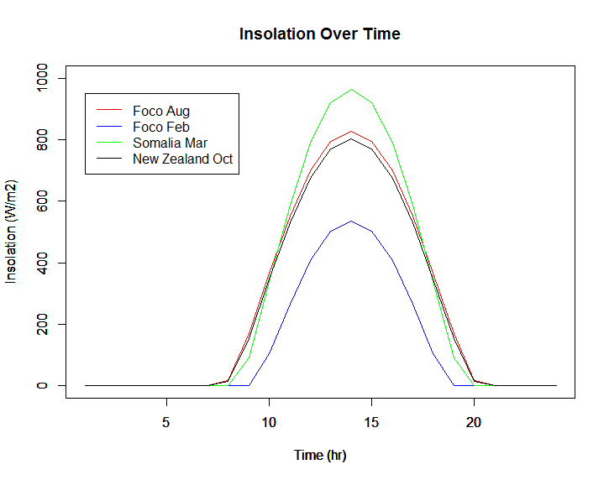
Figure 1. Insolation of one day for four locations and days on Earth.
Problem #2
time.step=3600
albedo=0.08
hours.per.lunar.day <- 24 * 29 + 12.75
n.lunar.days <- 10
n.steps <- n.lunar.days * hours.per.lunar.day * 3600 / time.step
heat.capacity <- 4.4e6 # (J/m3 per Kelvin, from Colozza 1991, pages 2-3)
thermal.conductivity <- 0.025 # (W/m per Kelvin, also from Colozza 1991)
sigma <- 5.67e-8 # (W/m2/K4, Stefan-Boltzmann coefficient)
solar.constant <- 1367. # Watts/m2
n.layers <- 15
dz <- rep(NA, n.layers) # layer thickness (meters)
depth <- dz
dz[1] <- 0.02 # Top layer is thinnest (2 cm)
depth[1] <- dz[1] / 2
layer.mult <- 1.5

for (L in 2:n.layers) {
dz[L] <- dz[L-1] * layer.mult
depth[L] <- sum(dz[1:(L-1)]) + dz[L] / 2
}

empty <- rep(NA, n.steps-1)
R.net <- empty
SW.down <- empty
SW.up <- empty
LW.down <- empty
LW.up <- empty
lunar.date <- empty

soilT <- matrix(NA, nrow=n.layers, ncol=n.steps) # array to hold soil temps (Kelvin)
soilT[ , 1] <- 273. # Initial soil temps = 298 K = 25 C

flux <- matrix(NA, nrow=n.layers+1, ncol=n.steps-1) # array to hold heat fluxes (W/m2)
flux[ ,1] <- NA # upward flux at top of layer L

elapsed <- 0

for (i in 1:(n.steps-1)) {

# Calculate date and time (lunar solar time = LST)
elapsed <- elapsed + time.step
hours <- elapsed / 3600.
lunar.date[i] <- hours/hours.per.lunar.day
day <- floor(lunar.date[i])
LST <- hours - (hours.per.lunar.day * day)

# Calculate position of Sun in Lunar sky
hour.angle <- -pi + (LST / hours.per.lunar.day) * 2 * pi
cos.z <- max(cos(hour.angle), 0.)

# Calculate SW gain using Bonan (Chapter 4)
SW.down[i] <- solar.constant * cos.z
SW.up[i] <- SW.down[i] * albedo

# Calculate LW using sky temp = 5 Kelvin
LW.down[i] <- sigma * 5^4

# Upward longwave from surface assumes blackbody (emissivity = 1)
LW.up[i] <- sigma * soilT[1,i] ^ 4

# Net radiation
R.net[i] <- SW.down[i] - SW.up[i] + LW.down[i] - LW.up[i]

# Soil temperature

# Compute upward flux at top of each layer
flux[1,i] <- -R.net[i] # top flux boundary condition
for (L in 2:n.layers){
flux[L,i] <- -thermal.conductivity * (soilT[L-1,i] - soilT[L,i]) / ((dz[L-1]+dz[L])/2)
}
flux[n.layers+1,i] <- 0. # bottom flux boundary condition

# Compute new temperatures for each layer
for (L in 1:n.layers) {
soilT[L,i+1] <- soilT[L,i] - (flux[L,i] - flux[L+1,i]) * time.step /
(heat.capacity * dz[L])
}

}

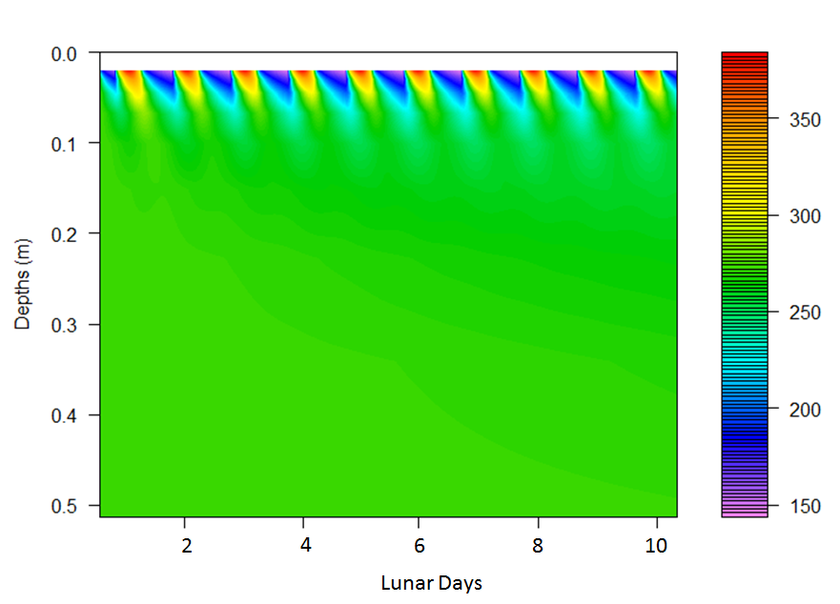
Figure2. Temperature by depth for 10 lunar days.

