Alicia Tyson
ATS 761: Land-Atmosphere Interactions
Assignment #1

- Fort Collins, CO USA on August 21 (P=855mb)
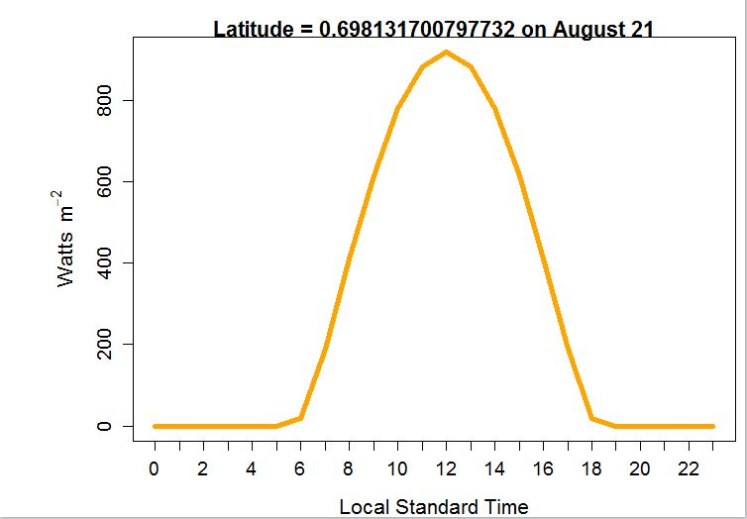

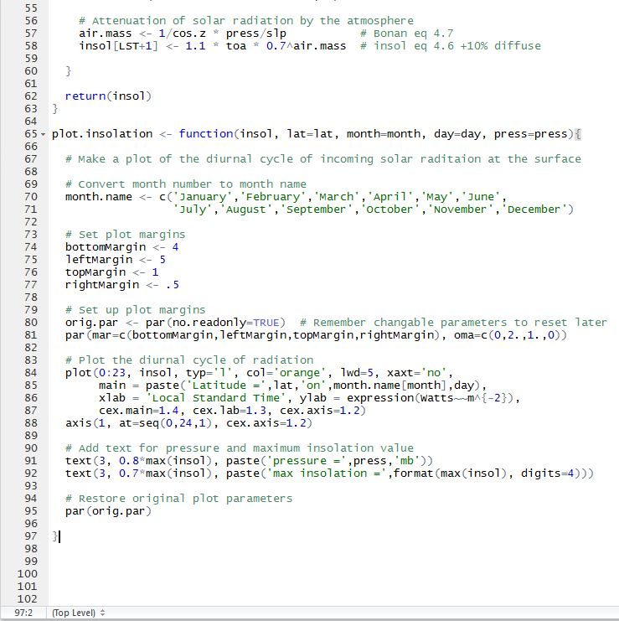
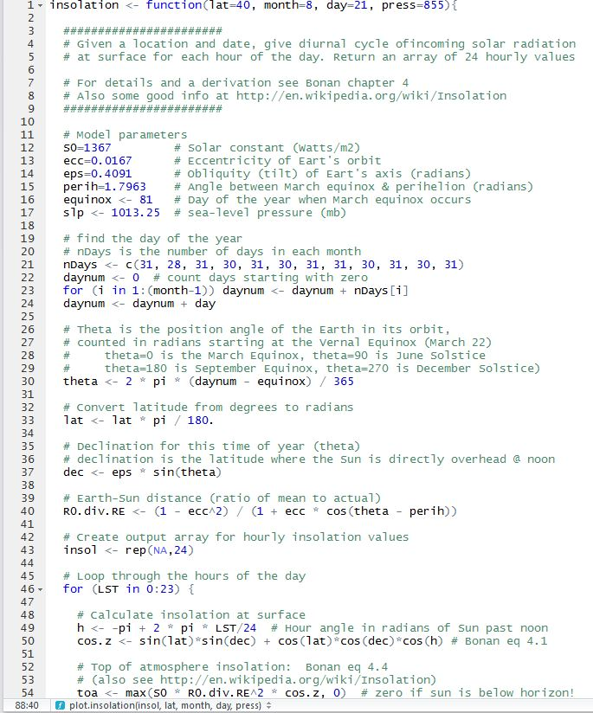
Fort Collins, CO USA on February 21 (P=845mb)
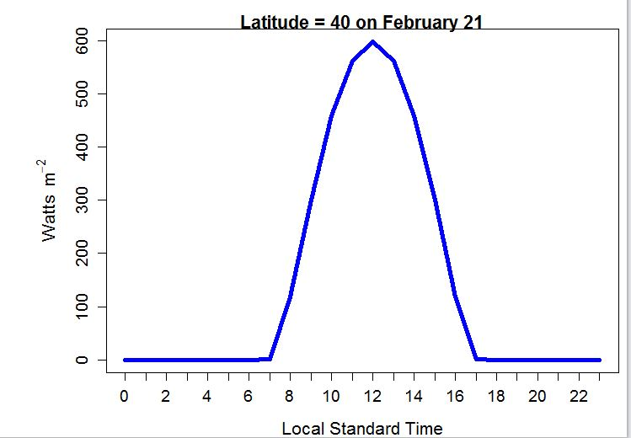

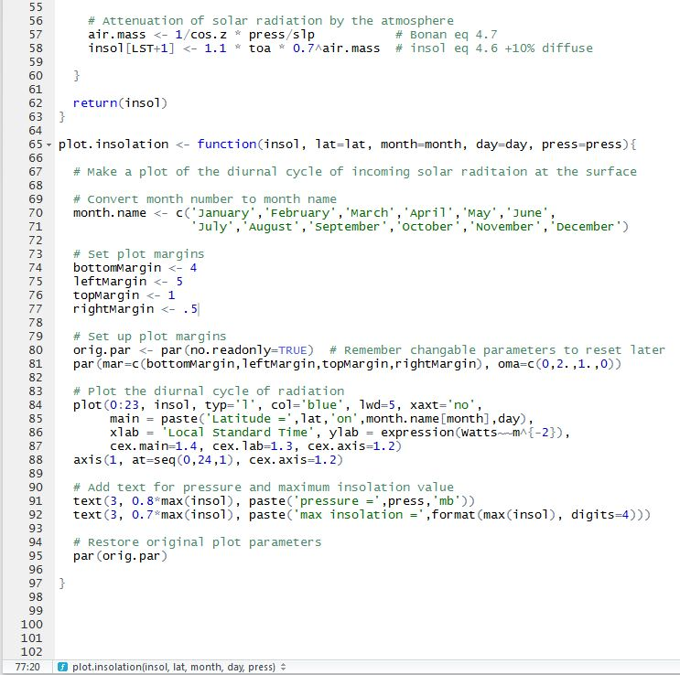
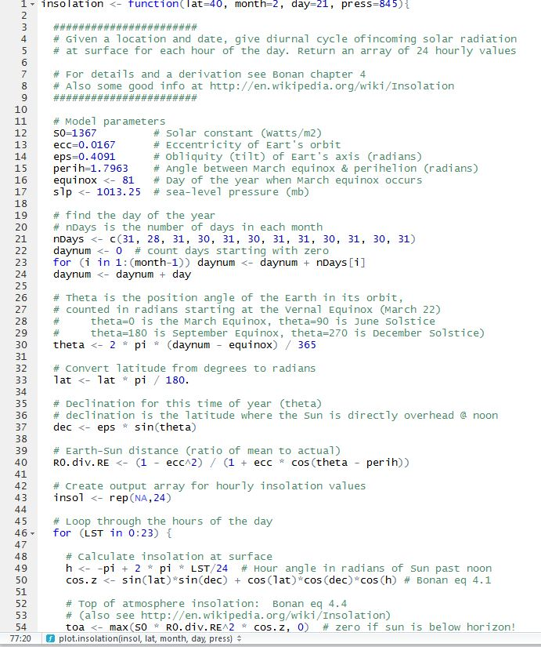

Mogadishu, Somalia on March 21 (P=1010mb)
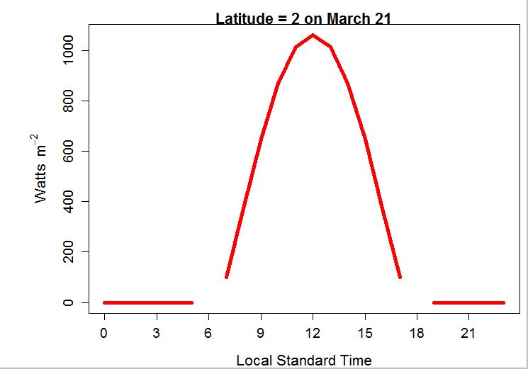

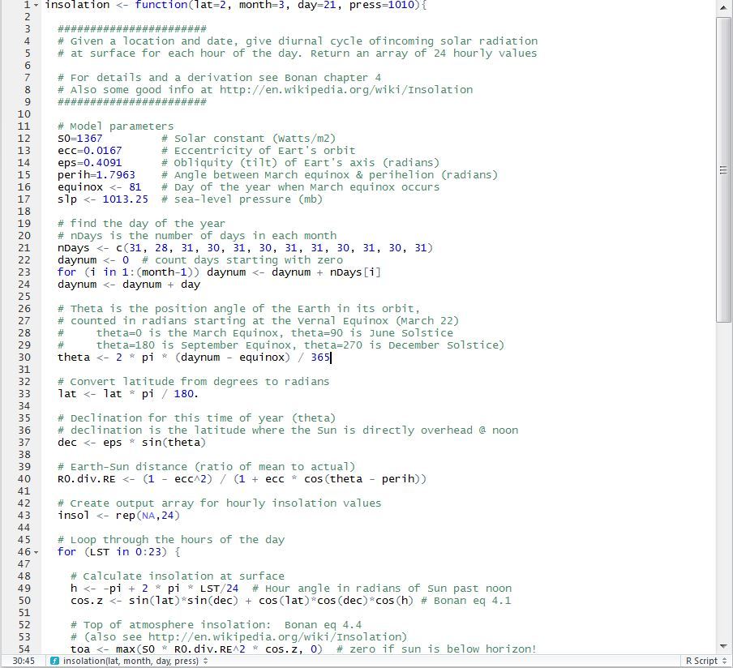
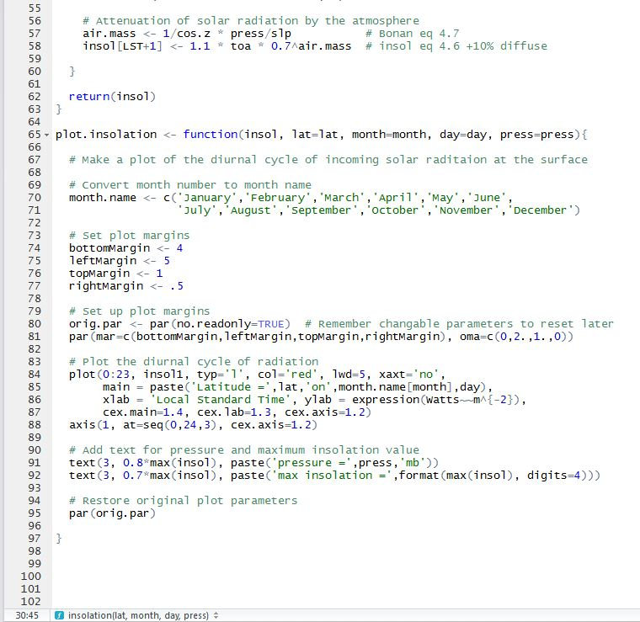

Wellington, New Zealand on October 21 (P=1010 mb)
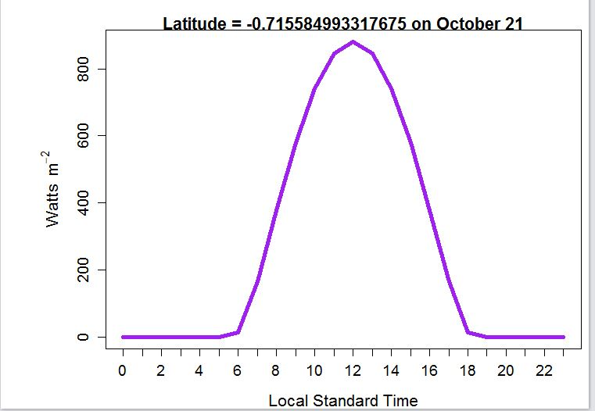

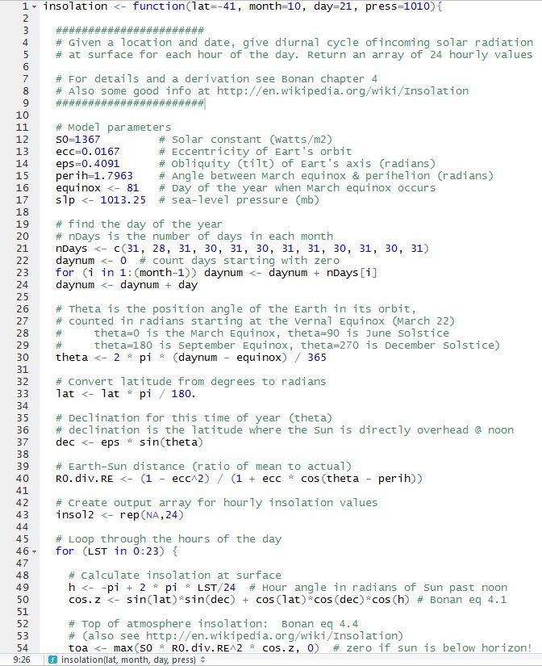
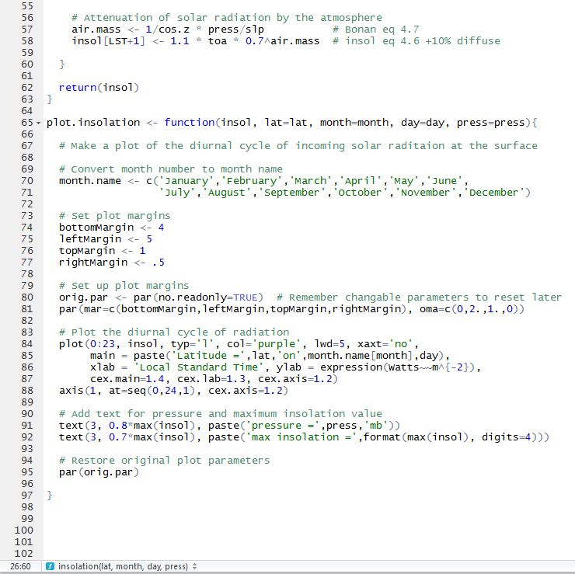

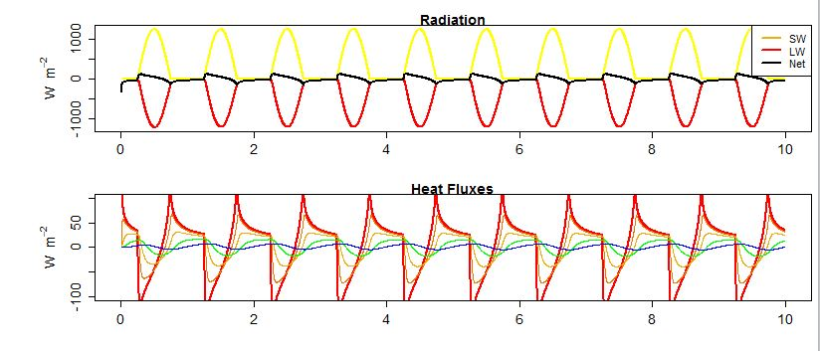
- Graphs below represent average “daily” variations of surface temperature on the Equator of the Moon at 4.5 hr time steps. Note: I could not get the Temperature panel to run. I tried multiple time steps…1 hr, 2 hr, and 4.5 hours. The graphs below of radiation and heat flux are based ona 4.5 hr time step. I repeatedly received the error shown below when trying to run the Temperature panel. I tried Googling the error message and changing the x and y axis parameters and it did not make a difference. I assume my unfamiliarity with the program is contributing to my inability to solve the problem.

Error Message Received When Trying to Run Temperature Panel
