Regional and Global Estimation of Terrestrial CO2 Exchange from NIGEC Flux Data
DOE NIGEC
1998-2000
Abstract
This investigation sought to bridge the gap between detailed eddy flux measurements made at local scales (for which regional representativeness is difficult to establish) and regional information provided by inversion studies (whose results are difficult to apply to particular ecosystems because of their coarse resolution). Inverting atmospheric observations using simulated tracer transport over vegetated land surfaces requires careful evaluation of interactions among surface energy budgets, ecosystem carbon flux, and atmospheric turbulence and convection (the “rectifier effect”) which can confound the inversion procedure: we sought to evaluate this effect in nature and in a series of models. Technical and financial obstacles preclude a flux network of sufficient density to resolve sub-regional spatial patterns in carbon flux: we worked to develop a testable method for extrapolation of these fluxes using modeling, remote sensing, and atmospheric data.

We have coupled a self-consistent model (SiB2) of biophysical and biogeochemical exchanges at the land surface to local-scale turbulence models, to a mesoscale model, and to an atmospheric GCM. Vegetation is parameterized according to satellite imagery, and the models predict observable quantities such as energy fluxes and CO₂ concentrations. The coupled models are quite successful at predicting variations of latent and sensible heat fluxes, CO₂ fluxes, and CO₂ concentrations at multiple spatial scales. Simulations at the regional scale have been used to design sampling strategies for testing “bottom-up” estimates of fluxes using concentration measurements made from aircraft.
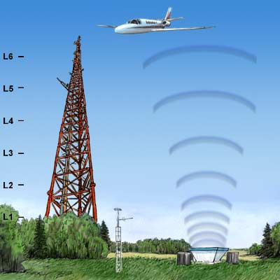
Proposal
Final Report
Publications
Students

