Regional ecosystem-atmosphere CO₂ exchange via atmospheric budgets
DOE Terrestrial Ecosystems
2002-2005
We propose to estimate regional fluxes of CO₂ by three independent and complementary methods, in order to develop and test modeling and observational methods. We will evaluate the utility of continuous, highly accurate measurements of the mixing ratio of CO₂ in the atmospheric surface layer for regional flux estimation by inversion of a mesoscale transport model. Regional flux estimates will be compared to calculations made by a gridded ecophysiological model (from the “bottom up”), and to estimates from a highly resolved global data assimilation model (from the “top down”).
Instrumentation for a regional network of six to eight high-precision, high-accuracy CO₂ mixing ratio measurements will be developed and deployed on a regional network of surface layer flux towers. Two regional experiments will be conducted, one during the growing season and one during a season of net respiration. Airborne measurements will also be employed whenever possible. This regional network of CO₂ measurements will be nested so as to sample CO₂ mixing ratio changes over the course of a few hours (tower spacing of ~100km) and over the course of a day (tower spacing of ~400km). These methods will be important components of the planned North American Carbon Program.
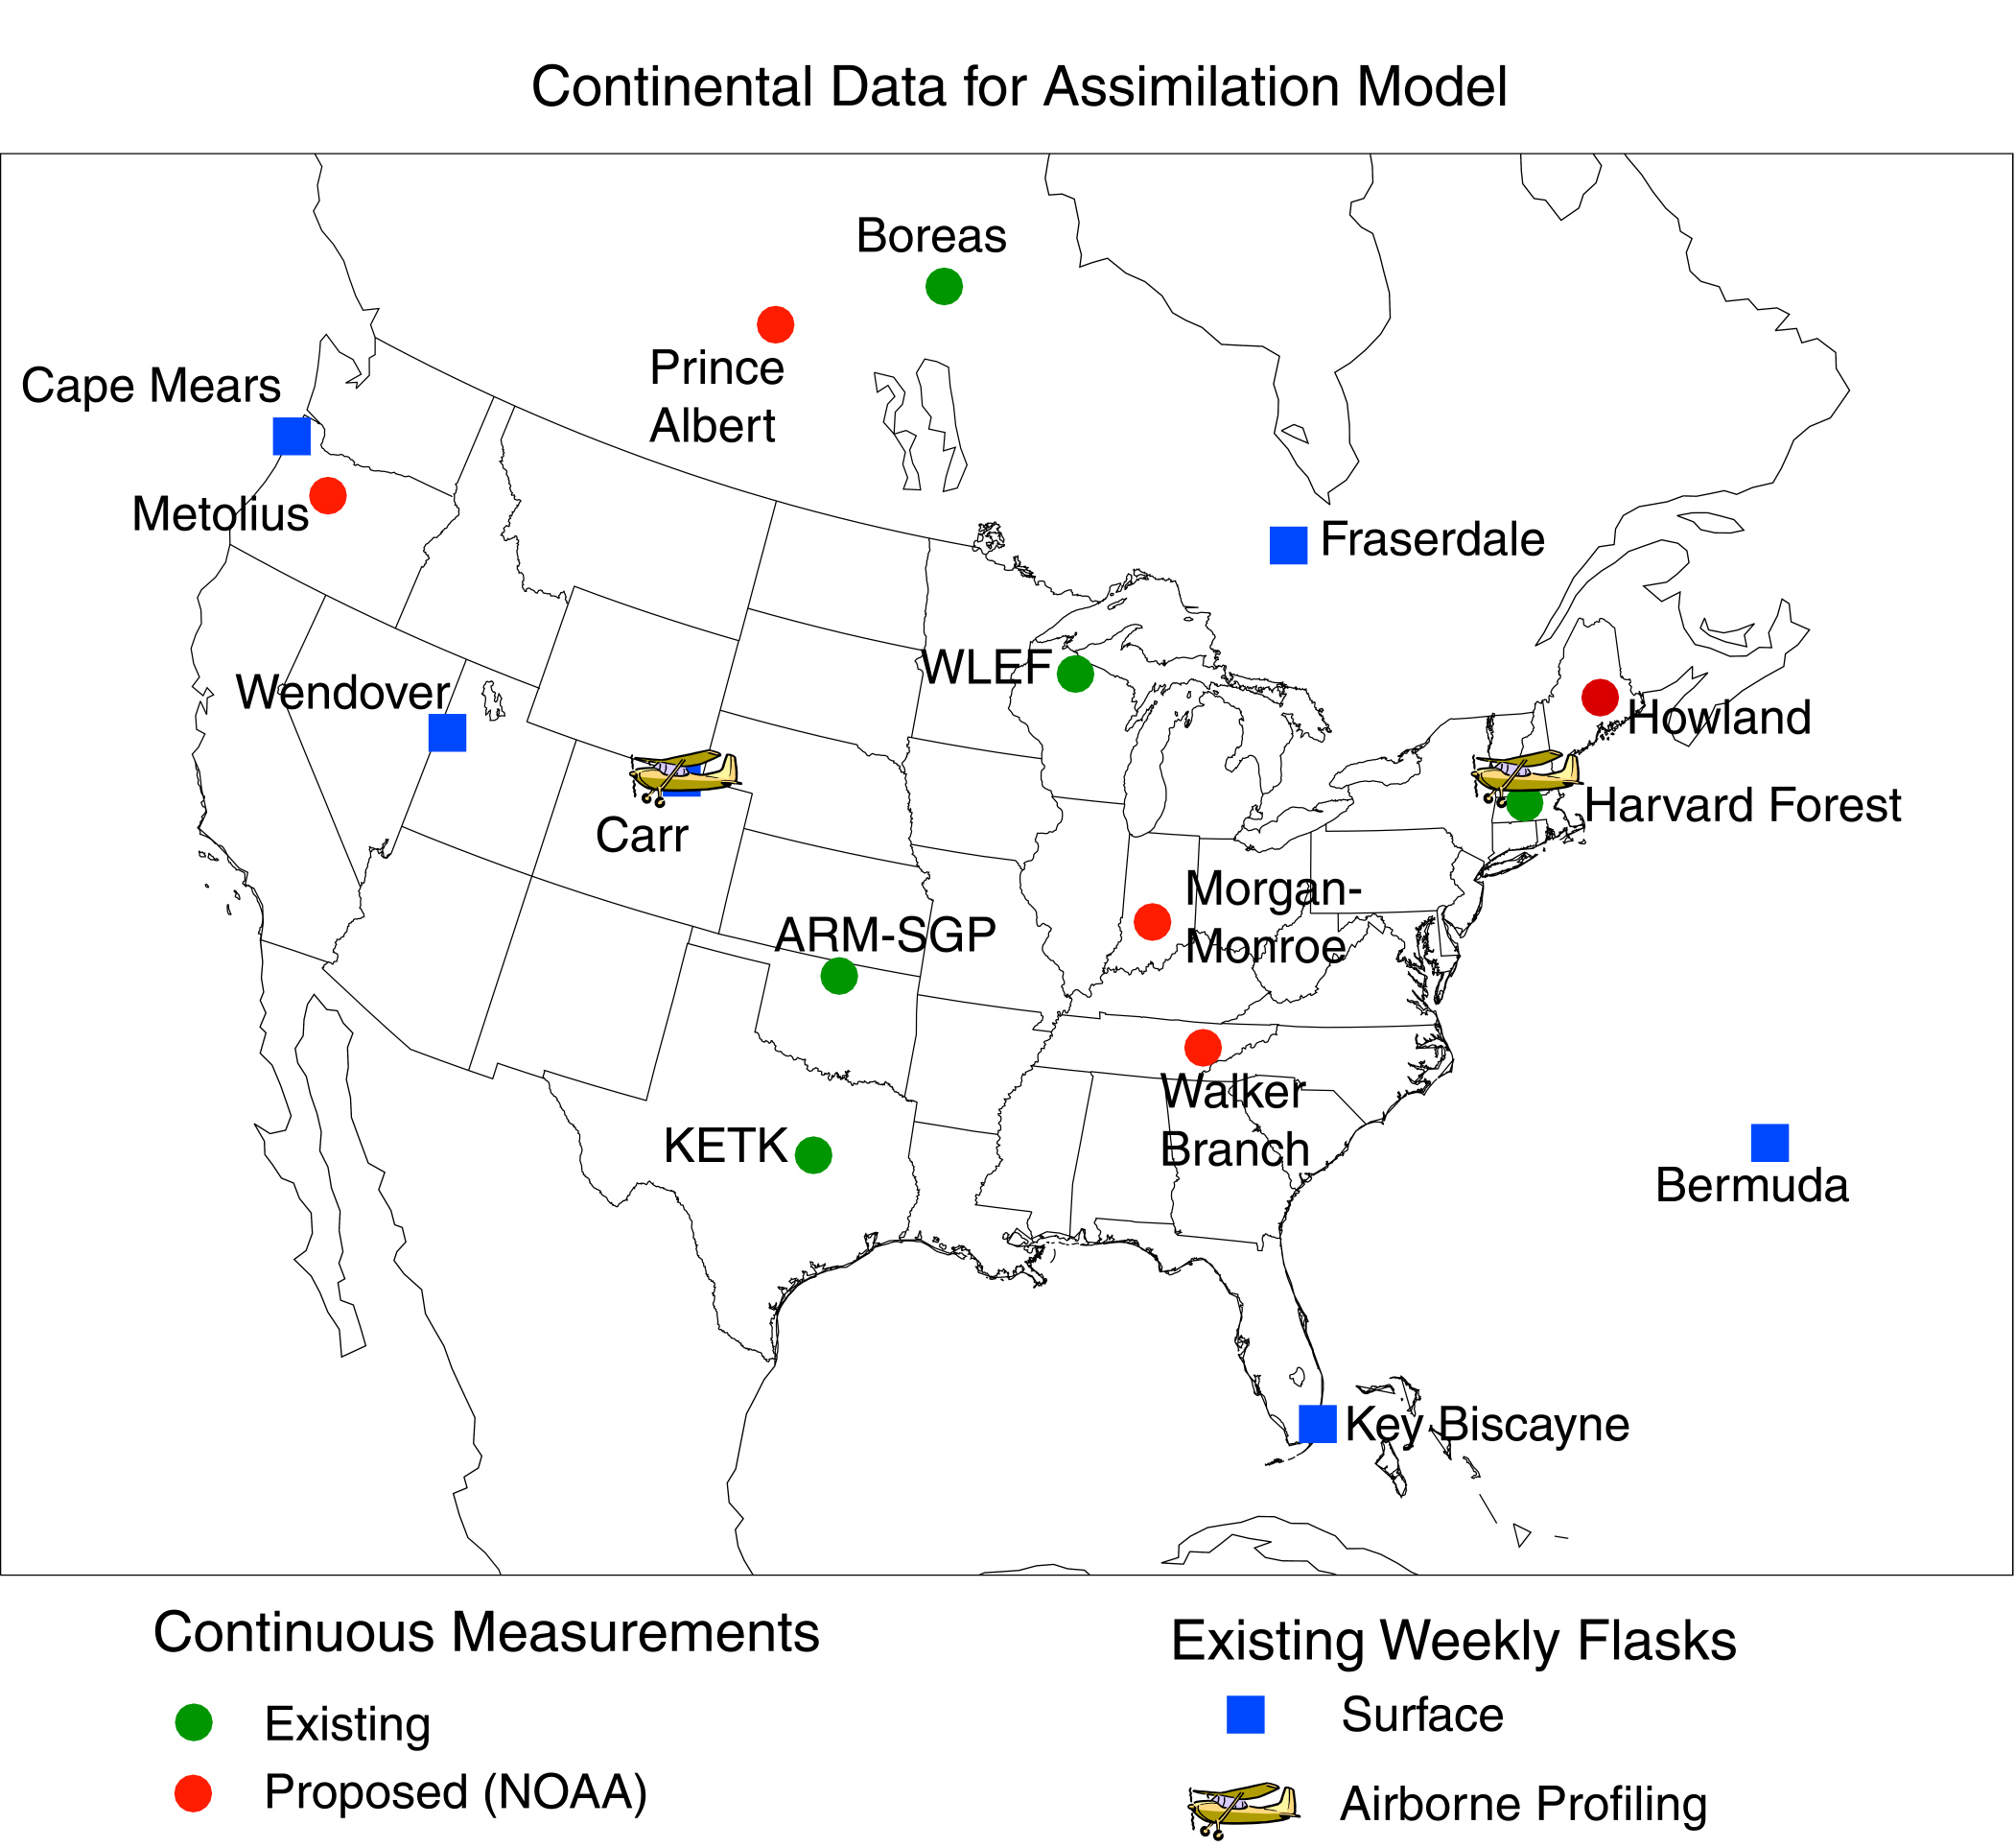
Figure 2: Locations of sampling sites to be used for global data assimilation
Full Proposal
Final Report
Publications
Students

