Constraining the CO2 Missing Sink
NASA
2005-2007
We developed, implemented, evaluated, and published results from a suite of numerical models of the terrestrial carbon cycle and its interaction with atmospheric constituents (CO2, COS). These efforts were part of a larger research program directed at NASA Goddard Space Flight Center led by S. Randall Kawa and colleagues. We report here on (1) work we did to couple the ecophysiology model SiB with a biogeochemical cycling model (CASA); (2) an investigation of the role of terrestrial ecosystems in the uptake of carbonyl sulfide (COS); (3) the mechanisms controlling synoptic variations of CO2; and (4) the development and evaluation of an ensemble data assimilation system for analyzing measured variations in atmospheric CO2. This report also lists graduate students supported, publications and conference presentations supported by the project.
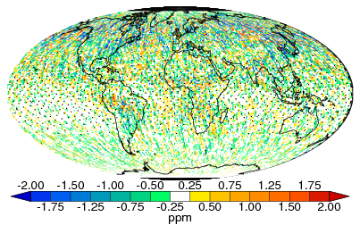
Figure 6: Annual mean temporal sampling errors, obtained by subtracting the annual mean at each grid cell from the annual mean in the OCO s
Full Proposal
Final Report
Publications
Students

