Regional Transport Analysis for Carbon Cycle Inversions

NOAA
2005-2007
Working closely with colleagues at NOAA, we have obtained test data sets of hourly meteorological analyses generated by the Rapid Update Cycle (RUC) assimilation system on the 13-km grid over North America. We developed and tested subsetting software to extract only the transport fields from these analyses, and adapted the CSU Lagrangian Particle Dispersion Model (LPDM) to read the 13-km RUC fields. We have now verified that we can calculate adjoint, or backward-in-time, transport influence functions for specified sampling stations to quantify the sensitivity of each observation at NOAA sampling towers to unit surface fluxes of CO₂ or other trace gases at all points upstream in the RUC domain.
For each data point, i.e., tower location and sampling time (1 hour or longer), a separate influence function is derived which depends on spatial coordinates of source areas as well as release time of fluxes from the surface. Therefore, the RUC-LPDM system is generating a huge amount of data, which would be impractical to store and disseminate at full resolution for a year.
Figure 1 presents a series of influence functions [ppm/umol] calculated during testing the prototype RUC/LPDM system. They are derived for the 10-day period of March 6-16, 2006 and hypothetical 400 m towers spaced every 1000 km across the RUC domain. The influence functions are integrated with unit CO₂ flux from the surface (1 umol/m²/s). In a similar manner the influence functions can be derived for all active NOAA towers (or any other locations of interest) and can be integrated with the user provided CO₂ fluxes instead of the unit flux.
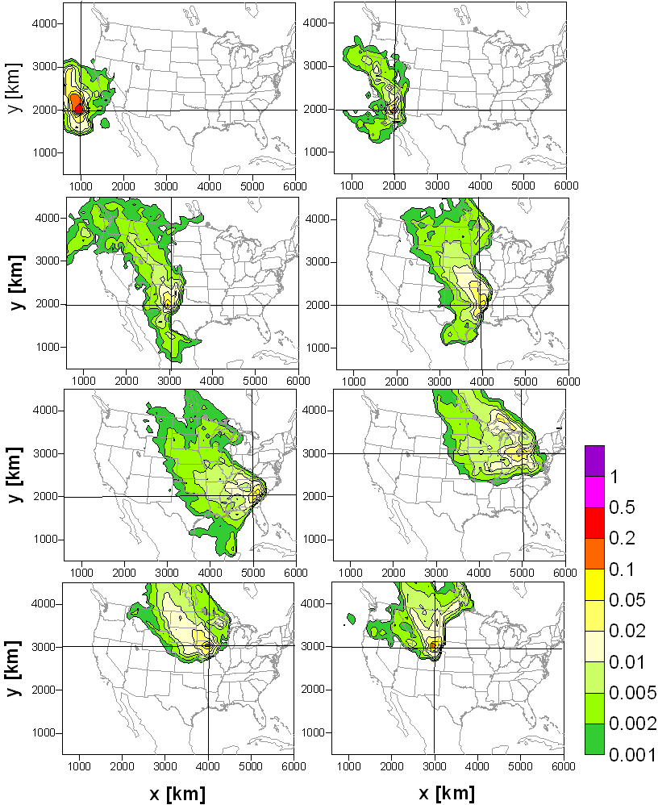
Full Proposal
Final Report
Publications
Students

