Resolving CO₂ Flux Estimates from Atmospheric Inversions and Inventories in the Mid-Continent Region
NASA
2008-2010
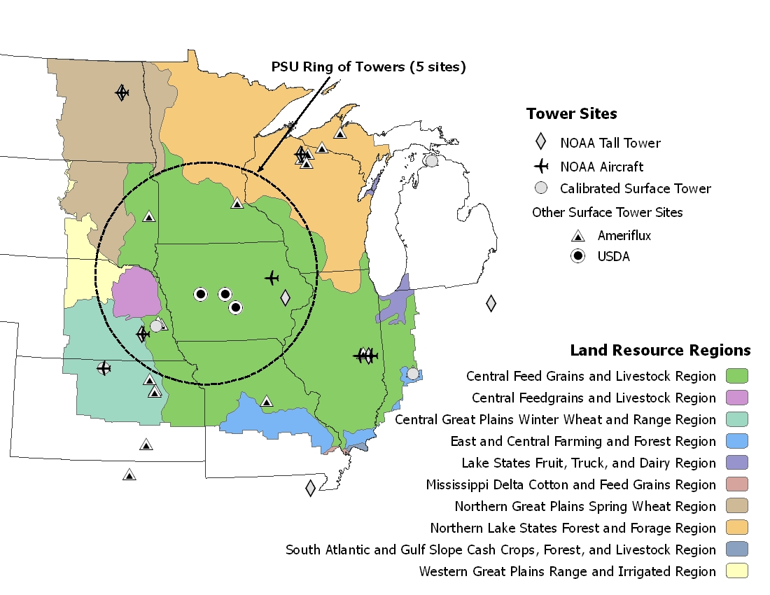
Atmospheric inversions and inventories represent two lines of evidence on CO2 fluxes at large spatial scales, but these approaches often do not provide consistent results. Inversions rely on CO2 concentration measurements to infer fluxes between the terrestrial surface and atmosphere. Inventories are typically conducted using models to predict changes in C pools, or CO2 fluxes directly, based on various driving variables influencing uptake and release of CO2 from the terrestrial surface. Our objective is to reconcile estimates between these approaches, to the extent possible for the Mid-Continent Intensive (MCI) Study Region of North America, shown in Fig. 1.
Fig. 1: Region of interest for MCI study

Full Proposal
Final Report
Publications
Students

