Questions:
- How powerful are you?
- What’s your personal radiative power output?
- From where do you receive radiative input?
- Do your power output and inputs balance?
- If not, by how much are they out of balance?
- How do you personally balance your energy budget?

Materials:
- Handheld IR thermometer
- Measuring tape
- Calculator

What to Do:

Divide into small groups, and provide each group with a handheld infrared thermometer. Ask each group to explore their immediate environment with the IR thermometers. What’s the coldest temperature they can find in the room? What’s the hottest?

Watch out! The IR thermometers have a laser pointer to show the user what they are pointing at, but the laser has nothing to do with the temperature measurement! A very common misconception is that the temperature readout is for the spot where the laser shows up. But in reality the thermometer reads the average temperature in its field of view, which is a cone about 15° across. So if you point it across the room the laser may fall on a light bulb but the readout is probably an average of the whole wall, ceiling, and people over there. Students will probably be confused about this.

Who’s the hottest person in the group? Measure temperature of a person’s clothes, their skin, their glasses (no lasers in the eyes please!), the inside of their mouths!

Now ask them to measure the temperature of the walls, the ceilings, the floor, the tables.

Ask each group to “report out” with a ballpark estimate of the temperature of the temperature of a person and the temperature of the emitting surfaces in the room. Try to come to a classroom consensus on a single “personal” temperature and a single “environmental” temperature. Lead them through a thought process that includes taking an average of temperatures by area (faces have less area than shirts, for example), and windows have less area than ceilings). Also be sure to use consistent units (Fahrenheit? Celsius?). Note that the radiative temperature of a person is far below their internal temperature (under the tongue, for example, to decide if they have a fever). Also discover that the radiative temperature of the room is often quite different from the air temperature.
One last thing: use the measuring tape to estimate the average height and diameter of a person.
Convert units to get height and radius in meters. You’ll have to be creative because people are oddly shaped! But we’re going to simplify by approximating people by cylinders.
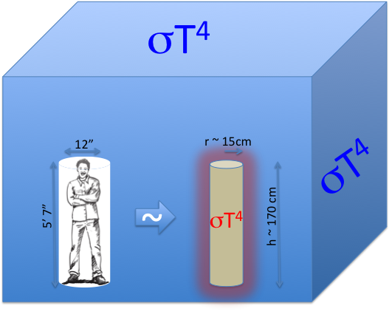
Calculation: Net radiative balance of a person

Net rate of energy loss = energy flux out minus energy flux in
$$F_{net}=F_{out}-F_{in}$$
$$F_{net}={{σT}^{4}}_{person}-{{σT}^{4}}_{env}$$
Symbols:
T_{person} is radiating temperature of the “person” (outside of their clothes)
T_{env} is radiating temperature of the “environment” (area-weighted average)

Both temperatures are in Kelvin!
[Kelvin = Celsius + 273, Celsius = (Fahrenheit – 32) / 1.8 ]
σ is the Stefan-Boltzmann constant (= 5.67 x 10⁻⁸ Watts m⁻² Kelvin⁻⁴)
[Discussion questions: Who was Stefan? Who was Boltzmann?
Where does this number come from? What do the units mean?]
F_{in} is the rate of energy flow (power!) into the person
F_{out} is the rate of energy flow (power!) out of the person
F_{net} = F_{in} – F_{out} is net radiative gain by the person (in Watts m⁻²)

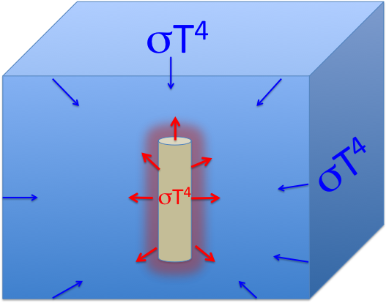
Example:
People-power!
If a person’s radiating temperature is 30 °C, then that person is radiating at a rate of
${{σT}^{4}}_{person}={σ(30+273 K)}^{4}$
= (5.67 x 10⁻⁸ Watts m⁻² Kelvin⁻⁴) x (303 Kelvin)⁴ = 478 Watts m⁻²
So every square meter of the person is radiating 478 W of power.
A person who is 5’7” tall and 12” across has about the same surface area as a cylinder 170 cm (1.7 m) tall with a radius of 15 cm (0.15 m). Their surface area is therefore about
A_{s} = 2 π r² + (2 π r)h = 2 π (0.15 m)² + (2 π 0.15 m)(1.7 m) = 1.7 m²
So the total radiative power of that person is
(478 Watts m⁻²) x (1.7 m²) = 813 Watts
This powerful person emits as much energy as a dozen 60-Watt light bulbs!
Recharging!
If the area-averaged radiative temperature of the room is of 22 °C, then the environment emits
σ (22 + 273 K)⁴ = 430 Watts m⁻². The person in the middle of the room is absorbing this radiation over her surface area of 1.7 m2, so she’s receiving energy from the environment at a rate of
(430 Watts m⁻²) x (1.7 m²) = 731 Watts
Finally, the net loss of energy from the person is 813 Watts – 731 Watts = 82 Watts.
Personal Energy Balance
Reminder: 1 Watt = 1 Joule per second
(82 Joules per second) x (60 seconds/min) x (60 min/hour) x (24 hour/day)
= 7,084,800 Joules per day of energy loss
1 “dietary calorie” (also known as a kilo-calorie or kcal) = 4184 Joules
So this person loses (7,084,800 Joules/day) / (4184 kcal/Joule)
= 1693 dietary calories just staying warm!
This is about the average base (resting) caloric requirement for an adult diet.

