By definition, the concentration of a gas ***X*** with an “atmospheric lifetime” of *** *** given by

 .

If the radiative forcing of the gas per unit of concentration is ***FX***, then the **cumulative radiative forcing** over a period of ***T*** years is computed by multiplying ***FX*** times the integral of the concentration over time:

 .

For simplicity, let’s assume that CO2 has an atmospheric lifetime ***CO2*** = 200 years. (Actually the lifetime of CO2 is best represented as a sum of three exponentials). Then the cumulative radiative forcing over ***T*** years due to an initial pulse of CO2 is

 .

Similarly, for some other gas ***Y*** with atmospheric lifetime ***Y ***

 .

For gases other than CO2, we define the **Global Warming Potential** as the *ratio of the cumulative radiative forcing of the gas to the cumulative radiative forcing of CO2 over some time period.*

Suppose at time zero, we emit 1 ppm of gas ***Y***. Then, we can write the **Global Warming Potential** of gas ***Y*** over ***T*** years by dividing equation 4 by equation 3:

 .

It is customary to define GWP in terms of the ***mass*** of a gas emitted rather than the number of ***moles*** (ppm or ppb by volume is equivalent to mole fraction). In this case, equation 5 can be easily rewritten to use relative masses as



where *MWY* is the molecular weight of gas *Y* (grams per mole) and *MWCO2* is the molecular weight of CO2 (44 grams per mole).

If we let ***G*** = ***FY***/***FCO2*** be the relative absorptivity of gas ***Y*** relative to that of CO2, equation 6 simplifies to

.

Evaluating definite integrals of exponentials is easy-peasy (see the inside cover of your old calculus textbook)!



or more simply

 .

**Example:**

Calculate the Global Warming Potential (GWP) of methane (CH4) over 20 years and over 100 years, assuming that methane has an atmospheric lifetime of 12.4 years and that each ppm of methane absorbs 60 x as much radiation as a ppm of CO2 :

From equation (6), the GWP of CH4 over 20 years is

.

Similarly, the GWP of CH4 over 100 years is

.

Here’s an R function for calculating GWP of a gas:

**GWP <- function(G=60, tau.Y=12.4, tau.CO2=200, MW.Y=16, T=20){**

**# Compute Global Warming Potential of a gas other than CO2**

**# Default parameter values are for methane (CH4)**

**# G is the relative absorptivity of a mole of the gas compared to CO2**

**# tau.Y is the atmospheric lifetime (e-folding decay time) of the gas**

**# tau.CO2 is the atmospheric lifetime of anomalous CO2**

**# MW.Y is the molecular weight of the gas (g/mol)**

**# T is the number of years over which the GWP is to be calculated**

**MW.CO2=44 # Molecular weight of CO2 (g/mol)**

**return(G * tau.Y/tau.CO2 * MW.CO2/MW.Y \***

**(1-exp(-T/tau.Y)) / (1-exp(-T/tau.CO2)))**

**}**

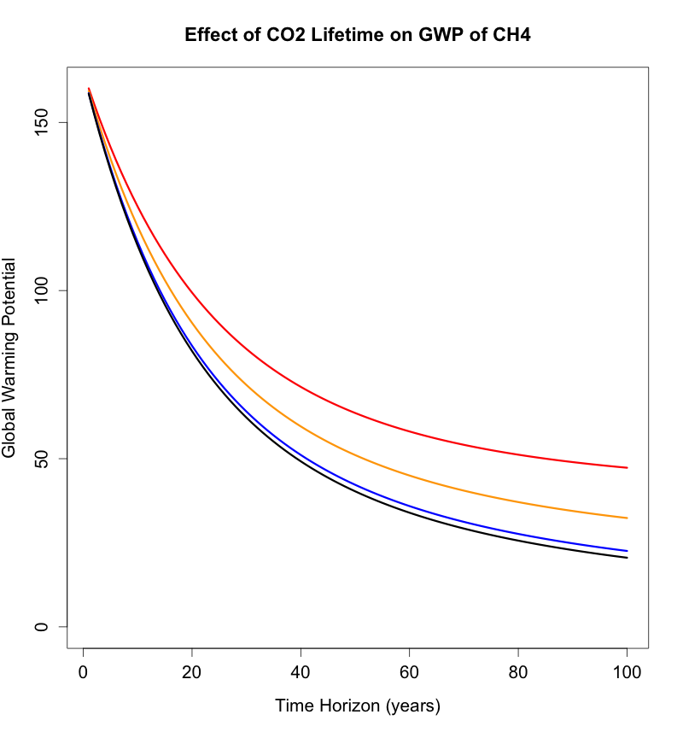Here’s the effect of the assumed CO2 lifetime on GWP of CH4:

CO2 = 50 yr

CO2 = 10000 yr



