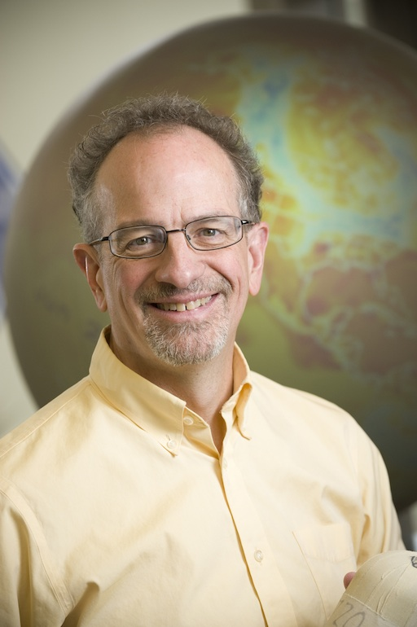
Climate 101:
How Climate Works
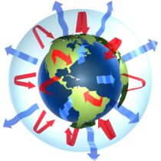
Learn how the Earth’s climate really works: how the Earth balances heat between incoming sunlight and the cold void of interplanetary space; heat storage in the tropics and the flow of heat to the poles by winds, weather, and ocean currents; the slow march of continents; the 1000-year conveyor belt of energy through the deepest seas; the relentless grinding of the polar ice.
Discover how climate changes in the past have shaped and been shaped by the Earth itself, and how the breathing of living things has developed.
Learn how people have adapted to climate, and how the Earth’s climate is changing today.

Professor Scott Denning, Atmospheric Science CSU
No textbook required: Two optional textbooks (see website)
LOCATION: Drake Hall 2545 Research Blvd Fort Collins
(off Drake between Shields & Taft, NOT ON MAIN CAMPUS)
Meets Five Times: 10 AM – Noon Fridays 9/20 through 10/18

